ifal

*)b&4*

\

«

FFICIAL INTERNATIONAL PUBLICATION OF THE ASSOCIATED LOCKSMITHS OF AMERICA, INC

**COMMUNITY CHEST**

Good will and good business in your own neighborhood during Crime Prevention Month

/



... ~~ ~

file Edit View Go Favorites Help

Address:| <http://www.ourcompany.com/home.htm/>

favorites

» f i

□ [www.ourcompany.com](http://www.ourcompany.com)

OiO

The Security Information Management On-Line Network



Reader Service #1

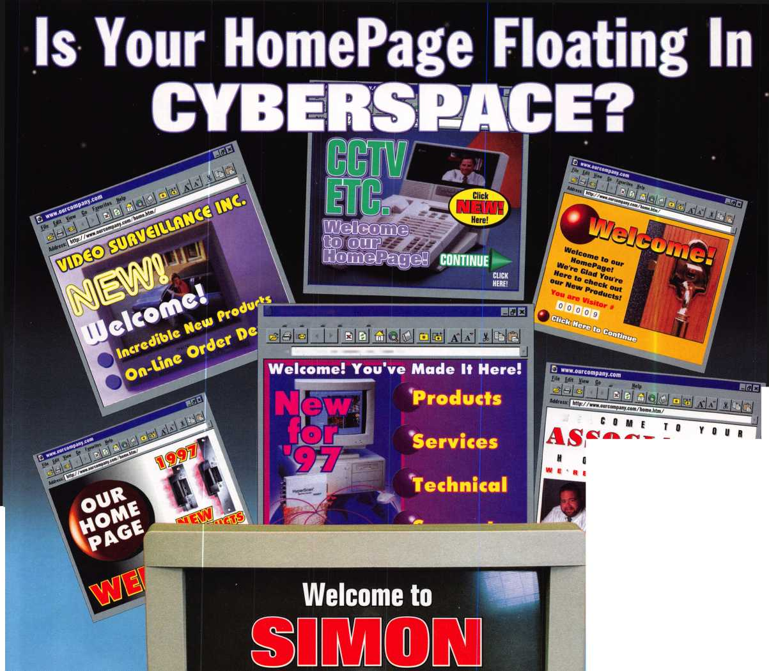

ALOA ’99 will be the coolest yet! Call for details: 800.532.2562, or visit our website: [www.aloa.org](http://www.aloa.org).

*asm*

p§i gpif

**I U LY 2 5-31**

Plan now to be in the coolest place of all next summer.

Dive into a class, make a splash at a seminar and wave to your friends as you drift through the nation’s largest exposition of locksmith related manufacturers.

Refresh your spirit with a visit to Fountain Square, a ride on a riverboat or by enjoying the breathtaking river view from Mt. Adams.



Contents

Features

**September**

4

President’s Journey

Membership participation is more possible now than perhaps in any other time in ALOA’s history. Make your mark.

By Dallas Brooks

15

Yours For the Asking

ALOA tracks legislation, and notifies members of pending bills that could affect their business. But did you know that the resources we use to do that are available to you too?

By Tim McMullen

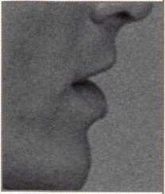

16

Who Are the Crime Prevention Experts?

Let’s take a moment to ask ourselves why professional locksmiths aren’t partnering more with other security professionals.

By Sal Dulcamara, CML

18

Point/Counterpoint: Licensing

Is licensing in the best interest of the profession? One says “Yes, and I can prove it.” The other thinks we need to keep an open mind and proceed with extreme caution.

By Sal Dulcamara, CML, and Kathy Zaniolo, CPL

20

Unusual Locks, Unusual Methods

The number of odd or unusual locks (compared to the vast  
number of standard locks) is very small. But knowing that

’t help when you’re staring one in the face. Here are

some servicing tips.

By Sal Dulcamara, CML

The Cover Does your community know that you, the professional locksmith, are their first line of defense against crime? Shouldn’t you tell them?

Cover illustration © Isabel Martinez

What Can You Do For Crime Prevention Month?

it takes some extra time and effort. But the dividends

are increased respect in your community and potential new  
clients for your shop.

By Mike Emery

25

Knob Nostalgia

In the Victorian era, everything from lock escutcheons to sash pulls to cabinet slide bolts were designed with an eye for aesthetics.

By Mark Ohno

Art direction/design Valerie Rowe

28

The Role of the Professional Locksmith

The professional locksmith has a unique opportunity to play an important part in the prevention of crime in today’s society.

By Steven Spiwak, CRL

30

Behind the Scenes

with ALOA Continuing Education

Walk backstage with this author and see ACE in action at ALOA ’98.

By Paul Chandler, CRL

September 1998

Mail Box

Words from the 1998 A.L.O.A. winner

Upcoming Events The fall brings numerous regional conventions, ACE classes and PRP sittings

Applicants for Membership

Scheduled for clearance October 1

32

Associate Members

12

Core

Another ASSA acquisition, some interviews with the new products winners from ALOA ’98, industry hirings and ALOA certification achievements.

31

Trade Tips

Motorcycles, keyboards and office equipment cylinders

AO

Security Marketplace

42

Keynotes Authors This Issue

44

Back Page

36

Classifieds

38

Buyer s Guide

42

Index to Advertisers

**J** Keynotes

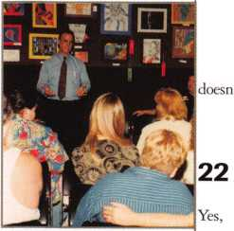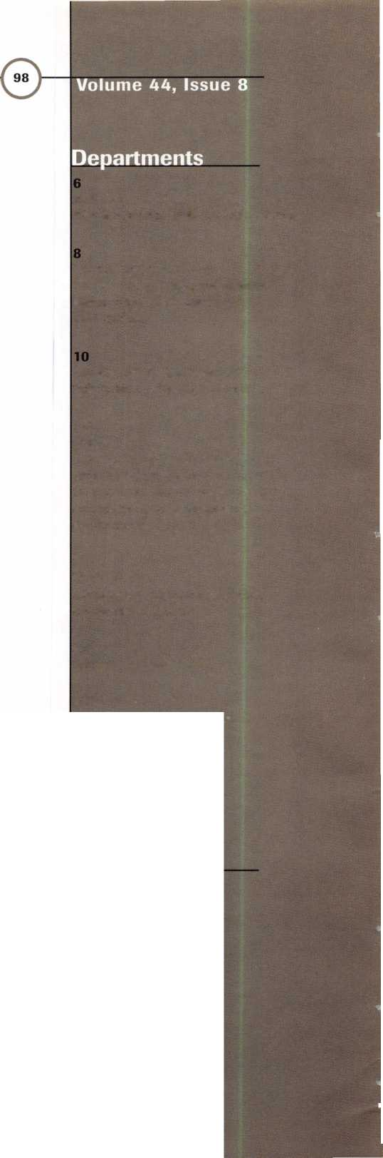

Staff)

**Executive**50301

'K

Editor

Associate Editor

Technical Editor

Editorial Advisor

Advertising Sales Manager

Sales Assistant Contributing Authors

ALOA Professional Staff Executive Director

Office Manager

Receptionist Comptroller Financial Assistant Meetings Manager

Meetings Assistant Government Affairs Manager

PRP/Education Manager

Education Assistant Membership Coordinator

Membership Assistant Chapters & Regional Associations Liaison

Anne McDonald Davis, ABC [keynotes@anet-dfw.com](mailto:keynotes@anet-dfw.com) Mike Emery [keynotes@anet-dfw.com](mailto:keynotes@anet-dfw.com) David Lowell, CML, CMS [david@aloa.ioffice.com](mailto:david@aloa.ioffice.com) John D. Cannon, CML [jdcannon@worldnet.att.net](mailto:jdcannon@worldnet.att.net) Anelia M. Banda [anelia@aloa.ioffice.com](mailto:anelia@aloa.ioffice.com) Sally Guereca Jerome V. Andrews, CML Paul Chandler, CRL Claire Cohen, CML Brian Costley, CML, CMS Bob De Weese, CPL Ray D’Adamo, CML Sal Dulcamara, CML James Glazier, CML Daniel Graffeo, CRL, CMS Wayne Gurnee, CRL A.J. Hoffman, CML Ken Holmlund, CRL Ray Lusk, CML Mark Ohno Randy Simpson, CML Steven Spiwak, CRL Robert Stafford, CPL Dave Thielen

Charles W. Gibson, Jr., CAE [charlie@aloa.ioffice.com](mailto:charlie@aloa.ioffice.com) Mary May

[mary@aloa.iofifice.com](mailto:mary@aloa.iofifice.com) Margo E. Vela Kathy J. Romo Debra Bradshaw Jessica Vasquez [jessica@aloa.ioffice.com](mailto:jessica@aloa.ioffice.com) Janelle Vergara Tim McMullen [tim@aloa.ioffice.com](mailto:tim@aloa.ioffice.com) David Lowell, CML, CMS [david@aloa.ioffice.com](mailto:david@aloa.ioffice.com) Ashley Spencer Brandon Durrett [brandon@aloa.iofifice.com](mailto:brandon@aloa.iofifice.com) Jackie Arnett

Tim McMullen [tim@aloa.ioffice.com](mailto:tim@aloa.ioffice.com)

Additional contact information for the ALOA Board and most Keynotes authors are available through “Locksmith Search’’ on the ALOA website- [www.aloa.org](http://www.aloa.org) or by contacting the ALOA office at 3003 Live Oak Street; Dallas, TX 75204; (.214)827-1701; FAX [214] 827-1810; e-mail [aloa@aloa.org](mailto:aloa@aloa.org).

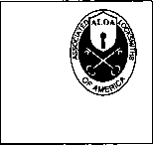

Mission Statement: The Associated Locksmiths of America. Inc. is dedicated to enhancing the professionalism, education and ethics among locksmiths and those in related sectors of the physical security industry. With approximately 10,000 members in the United States, Canada and the freeworld, ALOA is poised to help members obtain the knowledge, the strength, and the confidence to perform their role in the physical security field with pride and dignity. But it is only through active involvement and participation that ALOA can fully achieve its potential-and can help members to achieve theirs.

Policies: Keynoted is the official publication of the Associated Locksmiths of America, Inc. (ALOA). Keynotes® acts as a moderator without approving, disapproving, or guaranteeing the validity or accuracy of any data, claim, or opinion appearing under a byline or obtained or quoted from an acknowledged source. The opinions expressed by the authors do not necessarily reflect the official views of ALOA. Also, appearance of advertisements and new products or service information does not constitute an endorsement of products or services featured by the Association. The Association does not accept responsibility for the inaccuracy of any data, claim, or opinion appearing in this publication, due to typographical errors on the part of the authors, Association staff or its agents. Editor’s Note: This publication is designed to provide accurate and authoritative information in regard to the subject matter covered. It is provided and disseminated with the understanding that the publisher is not engaged in rendering legal or other professional services. If legal advice and other expert assistance is required, the services of a competent professional should be sought.

Authors’ Payment: Payment for eligible submissions to Keynotes will be based on the following criteria: topic, time spent and past contributions. Authors who regularly submit to Keynotes are generally paid a higher rate. The latter is especially true of authors who write to fit specific editorial needs and submit said copy by Keynotes deadlines. As a general guideline: Average payment for a 750 word, business or ‘light’ technical article would be $200. Payment for a 1500 word article involving significantly higher time and research efforts would be $400.

Payment will not be offered for articles submitted by ALOA employees or members of the ALOA Board of Directors (unless material is of a technical nature), nor for articles submitted by a company that promote that company's products or services. ALOA reserves the right not to pay for articles submitted by an individuals) that promote a particular company’s products or services.

Disclaimer: The Associated Locksmiths of America, Inc., (ALOA), reserves the right to refuse any article for any reason. Additionally, ALOA reserves the right to edit, amend or modify any article submitted for publication in order to preserve technical accuracy, clarity, fairness or grammatical correctness. ALOA will make the best efforts to notify the author of any changes. The extent of ALOA’s liability for any article or information contained therein will be a notice of correction or retraction in the next possible issue.

Keynotef (ISSN 0277 0792) is published monthly except for the combined June/July issue by The Associated Locksmiths of America, Inc., 3003 Live Oak St.. Dallas, TX 75204-6186. Telephone: (214) 827-1701: FAX (214) 827-1810; e-mail [aloa@aloa.org](mailto:aloa@aloa.org). Subscription rates for members-$15.00 per year. Second class postage paid at Dallas, Texas. POSTMASTER: Send address changes to: Keynotes, 3003 Live Oak St., Dallas, TX 75204-6186. © Copyright 1998, All rights reserved. No part of the contents may be reproduced or reprinted in any form without prior written permission of the publisher.



President

Dallas C. Brooks (334) 826-8990

Regional Vice Presidents Southeast

•Jeffrey S. Nunberg, CML, CMS

(305) 324-8800

North Central

•John J. Greenan

(773) 486-2030

South Central

•Randy L. Simpson, CML

1. 780-7026 Southwest

John I. Shandy, CML (303) 776-7898 Northeast James H. Glazier, CML (301) 831-5454 Northwest Raymond C. Lusk, CML (509) 624-3152 Secretary

John D. Cannon, CML (703) 960-6413

Trustees:

David M. Lowell, CML, CMS

(214) 827-1701

Breck H. Camp, CML ' -

(770) 455-6244

Henry H. Printz, CML

(201) 538-2737

Leonard J. Passarello, CPL

(416) 752-7210

Edwin Toepfer, RL

(416) 225-5589

Directors

*These officers also serve as directors.

Dana L. Barnum, CML

(610) 565-9900

Mark E. Blum, CML, CPS

(517) 482-5809

AJ. Hoffman. CML

1. 572-6008 Barry K. Leas, CRL (610) 650-9292

Clyde Roberson, CML, CPS (540) 380-5000 Donald E. Rule, CML (601) 324-2658

Anthony J. Ramunno, CML, CPS

(330) 782-6204

Robert H. Stafford, CPL

(860) 768-7917

Bruce J. Tarbet, CML

(601) 924-4184

Chairmen off International Affairs

Laurence P. Mills/Australia (129) 958-0445 Hans Mejlshede, CML/Europe FAX (453) 139-1004 Members-at-Large Jerome V. Andrews, CML (860) 621-3601 Steven G. Engel, CML, CPP (414) 731-5400

Past Presidents

1995-1997 David Lowell, CML, CMS 1993-1995 Breck Camp, CML 1991-1993 Henry Printz, CML 1989-1991 Evelyn Wersonick, CML 1987-1989 Leonard Passarello, CPL 1985-1987 Joe Jackman, CML 1983-1985 Stanley Haney, CPL 1981-1983 Louis LaGreco, CPL 1979-1981 John Kerr, RL 1977-1979 Clifford Cox, CML 1974-1977 Charles Hetherington 1972-1974 Gene Laughridge 1970-1972 William Dutcher, RL 1968-1970 Constant Maffrey, RL 1966-1968 Harold Edelstein, RL 1964-1966 William Meacham 1962-1964 Robert Rackliffe, CPL 1960-1962 Edwin Toepfer, RL 1956-1960 Ernest Johannesen

September 1998

Keynotes

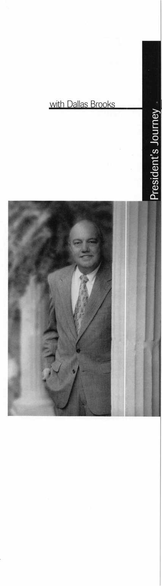

I have listened for years now to ALOA members making complaints such as:

“The Board is made up of a group of self-perpetuating good old boys who do  
not care about the needs of ALOA members.”

“I do not go to membership meetings because they are too long and too  
political for me.”

“I can not participate in the election of directors and officers of the ALOA  
board because I can not afford to attend every convention.”

“I do not know the ALOA board member in my region because he’s never  
been to one of our chapter or local association meetings.”

“My regional ALOA board member, elected at convention in 19XX, could  
not have been elected if only members in his region were voting for him.”

“If I had been able to attend the last annual membership meeting that  
‘Bylaws Amendment’ would not (or) would have passed.”

It has been my primary goal as your president to find a way to remedy these  
complaints. I sincerely believe, with the assistance of the new ALOA bylaws,  
approved by the members in attendance at the last membership meeting in  
Nashville, Tenn., we will achieve this goal.

The regional directors will be elected with votes from your region only.

The politics of electing directors is now in the hands of the regions. It is your  
responsibility to know the candidates in your region, choose the most qualified  
leader that will be responsive to your region and to hold him accountable for his  
actions as an ALOA board member. The ALOA board will no longer be a “group  
of self-perpetuating good old boys,” unless you make it so.

Under the new bylaws every member will receive a proxy mail-in ballot to  
vote on the election of directors, officers, and bylaws changes. No longer will you  
be required to attend a far away convention to vote. No longer should we hear  
the complaint of a membership meeting lasting till midnight. And, most  
importantly, we should never hear the complaint: “I can not participate in the  
election of directors and officers of the ALOA board.”

I believe, as did the majority of members present at the meeting in Nashville,  
the new bylaws are great and are necessary for the improvement of ALOA but  
one other ingredient is necessary for success—Membership Participation!

The success of our new voting process will soon be in YOUR hands. You will  
receive your ballot in the mail during the month of September. Please take a  
moment, mark your ballot, mail it back in and let your voice be heard! I am  
counting on all of you to participate. ALOA is now in your hands!

Dallas Brooks  
ALOA President



Keynotes

September 1998

|  |  |
| --- | --- |
| Kwok-kei Leung | 168 |
| Henry Raymond | 93 |
| Toshihiro Asano | 74 |
| Stewart Levine, CML | 67 |
| Mary Ohmit, CPL | 64 |
| Yuriko Yanai | 61 |
| Charles Robertson, CML | 58 |
| Jack Hobin, CPL | 51 |
| Allen Konrath | 49 |
| Salvatore Dulcamaro, CML | 38 |
| Myeong-Rae Cho | 36 |
| William Neff, CML | 35 |
| David Lowell, CML | 32 |
| Thomas Freehling, CML | 32 |
| John Heckman, CML | 28 |
| Jeanne Lodge, CML | 27 |
| J Thomas Hood, CML | 26 |
| Roy Renderer, CML | 25 |
| Danny Rudd, CPL | 24 |
| John Elliott, CML | 24 |
| Larry Warnick, CML | 24 |
| James Watt, CML | 23 |
| Robert Carroll, CPL | 23 |
| Diana Barnum, CRL | 22 |
| Barbara Watt | 22 |
| David M A Federico | 22 |
| Robert DeWeese, CPL | 22 |
| Jim Williams | 22 |
| Jerome Cohen, CML | 21 |
| Eugene Altobella | 21 |
| D Michael Lee, CPL | 18 |
| Charles Cole, CML | 18 |
| James Fowler, CML | 18 |
| David Harris, CML | 18 |
| Elvis Hammerschmidt, CPL | 18 |
| John Kerr. RL | 17 |
| Marian Swann, CRL | 17 |
| John Dorsey, CPL | 17 |
| Ronald Heidzig | 17 |
| Joseph Ferrero, CML | 16 |
| James Cawby, CML | 16 |
| William Grant, CRL | 16 |
| Scott Henke, CRL | 16 |
| Michael Robinson, CRL | 16 |
| Brian Reetz | 16 |
| Walter Lascar, RL | 15 |
| Thomas Vandersteen, CML | 15 |
| Gary Teams, CPL | 15 |
| William McElheney, CML | 15 |
| Philip Rovenolt, CPL | 15 |
| Rex Parmelee, RL | 14 |
| James Gruber. CRL | 14 |
| Edwin W Scott | 13 |
| Peter Gauthier, CPL | 13 |
| Paul Souber | 13 |
| Russell Fuller, CRL | 13 |
| Robert Rodocker, CRL | 12 |
| Frank Hartung, CML | 12 |

The Brightest

And The Best.



Rolando Bouza

Robert Duman, CML _ Lonnie McKinney, CML

Jon Griswold, CML

James Brickler, CRL _

Richard Sievers

Joe Lee, CRL

Eric Veal

Steven Spiwak, CRL

Herbert Dusenberry, CML

Robin Horsley

John Engel, CRL

Donald Shiles

Daniel Landry

Thomas Demont, CML_ Ernest Wright

William Wickward, CML

Lester Brodsky

Joseph Whitaker, CPL

Dale Knowles, CPL

_12

_12

_12

_12

_12

_12

_12

_12

_12

_11

_H

_H

_11

_11

_10

_10

_10

_10

_10

10

**How can I join the President's Club?**

You can earn membership in this prestigious club by recruiting just 10 new members for ALOA.

*Any ALOA member may participate.

**What do I get?**

When you recruit 10 members, you receive a handsome blue blazer with a President's Club crest. For each additional five members you recruit, you receive a lapel pin with gold-filled numbers, indicating your recruiting successes.

You also get the satisfaction of knowing that you are helping your association, helping your industry grow, and you are helping fellow locksmiths achieve success.

**How do I get started?**

Contact the ALOA office for a supply of applications (214) 827-1701 or FAX (214) 827-1810. One President's Club credit is awarded for each new applicant. Credit is awarded only after the membership application is approved. However, the credit will apply for the period in which the application is received. Failure to identify yourself as the sponsor on the application form at the time it is submitted to ALOA for processing will forfeit any credit.

*AL0A Board of Directors not eligibtefor membership in the President's Club.

**Keynotes**

Mail Box



Dept

If you have an opinion to offer on the letter(s) printed in Keynotes each month, let us know! Submissions to the “Keynotes Mail Box” department are printed on a space-available basis. Write to: Keynotes Mail Box;

Associated Locksmiths of America, Inc.; 3003 Live Oak Street; Dallas TX 75204; or FAX (214) 827-1810.

A Word of Thanks!

Those of you who were at the Awards Dinner and/or the Membership Meeting during the 1998 Convention in Nashville are aware that I was honored with the ALOA Lifetime of Outstanding Achieve­ment Award.

At the 1990 Convention, when I was awarded the Don Davis Memorial Award, I was walking in Cloud 9 for a long time. I thought there was no greater honor I could receive. Then this year, having made previ­ous plans, I missed the Awards Dinner. But when I arrived at the Membership Meeting, everyone came up and congratulated me, but wouldn’t tell me why. I assumed that I won some kind of award for giving the Education Manager and the President a hard time all week. But after the Membership Meeting started and I was called up to accept this award, the most prestigious of all awards, the ALOA Lifetime of Achievement Award,

I was completely at a loss of words. To be placed in the category with people such as the previous recipients, Edward Pfeil Sr., CML, Aaron Fish, Brian Costley, CML/CMS, Dan Graffeo, CRL/CMS, and Stanley Haney, CPL, is the highest honor that could ever be given to someone in the security profession. It will take me a very long time to get my head back to normal.

I would also at this time, like to give a special “Thank You” to Brian Costley for all the nice things (I think) that I heard he said about me during the presentation at the Awards Dinner. Thank you, Brian!

Sincerely,

Hal Tibbits, CML, Member #02448

Education and Getting Involved

Voting the new bylaws into effect will give past, present and future members a voice in their association. They can vote by mail to help relieve the cost of going to the national ALOA show. However, voting by mail should not keep them from going to take classes, see new products, pick up litera­ture and gripe or congratulate manufacturers on products. I know from past experiences that the classes are well worth going to. I

myself have taken classes taught by the same instructors just to pick their brains, and learn as many new things as I can. The instructors are screened closely by ALOA, and are all very qualified to teach. I took a class taught by Mark Blum in Reno [ALOA ’97] and hope he is asked to teach it again in Cincinnati. If he is, I will be there. I have taken Ray D’Adamo’s auto classes two to three years, back to back, and I always learn something new. These are just a couple of the instructors who I can think of off the top of my head, but all of them are great.

On to another education subject I would like to touch on. At lunch on the second day of classes at ALOA ’98, David Lowell [ALOA’s Education/PRP manager] asked for volunteers to assist the education office for a short period after class. After much thought I figured I would give it a shot. For those who know me, they know I am one who normally does not volunteer. I always had the idea of why get involved?’ but some­thing told me it was time to do something for MY association. Well after volunteering the first day, I found out it was not hard work, and volunteered the rest of the week. (Note: I would like to thank the other vol­unteers who assisted me as well as ALOA also.) At the banquet, Dallas recognized all the people who volunteered—this was not necessary for me, and it is not why I did it. I just wanted to be able to say, “I helped my association.” I have full intentions of volun­teering again next year, and every year I can go to the show.

I feel it is time for the members to quit sitting back and bellyaching, and start doing something. I used to sit back in the shadows and bellyache, now it is time for me to do something—I have decided to volunteer and to run for the ALOA board. People need to start voicing their opinions. We have now made a way for ALL members to have a voice in how the association is run. I feel that this is something that needed to be done. The members need to talk to their board representatives about problems, ideas and praises. They should have at least three ways to get in touch with them, be it phone

numbers, e-mail addresses or fax numbers. If they have these items, then they have no reason to complain about how things are run, and cannot say they did not have a rep­resentative to talk to or a voice in the deci­sion. I understand not all people will be happy, but now they can all give their opin­ions just like this author has done.

Please feel free to get in touch with me: phone (813) 689-5979, M-F, 9-5 EST, e-mail at ([Ernie28@ix.netcom.com](mailto:Ernie28@ix.netcom.com)), or fax at (813) 653-2217, 24hr.

James R. Barnhardt #13794

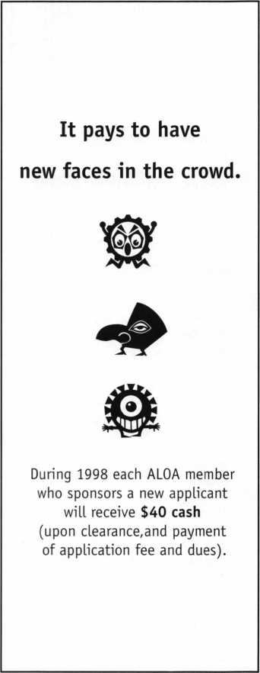

***Keynotes***

September 1998



Locksmithing is at war with big business.

But you have more firepower than you realize.

Your fellow locksmiths joined forces more  
than 40 years ago, understanding the need  
to fight battles together. Today, benefits of  
membership in the Associated Locksmiths  
of America, Inc. have grown far beyond

the early vision, but they still rest on one  
enduring truth: Strength in numbers.

Your best chance of surviving the struggle  
ahead is being a part of an organization  
with others like yourself. Through our

common voice we will refuse to be  
legislated out of business.

As a united front, we can command technical advice from world-renowned instructors and authors who know how to make our business boom.

It starts with you.

It ends with all of us together.

Recruit a member today.

For a supply of membership applications, contact:

Associated Locksmiths of America, Inc.

3003 Live Oak Street, Dallas, Texas 75204 Voice: 214.827.1701 Fax: 214.827.1810

Email: [jackie@aloa.ioffice.com](mailto:jackie@aloa.ioffice.com)

We’re Right Behind You.

ADVERTISING

NETWORKING

**FRIENDSHIP**

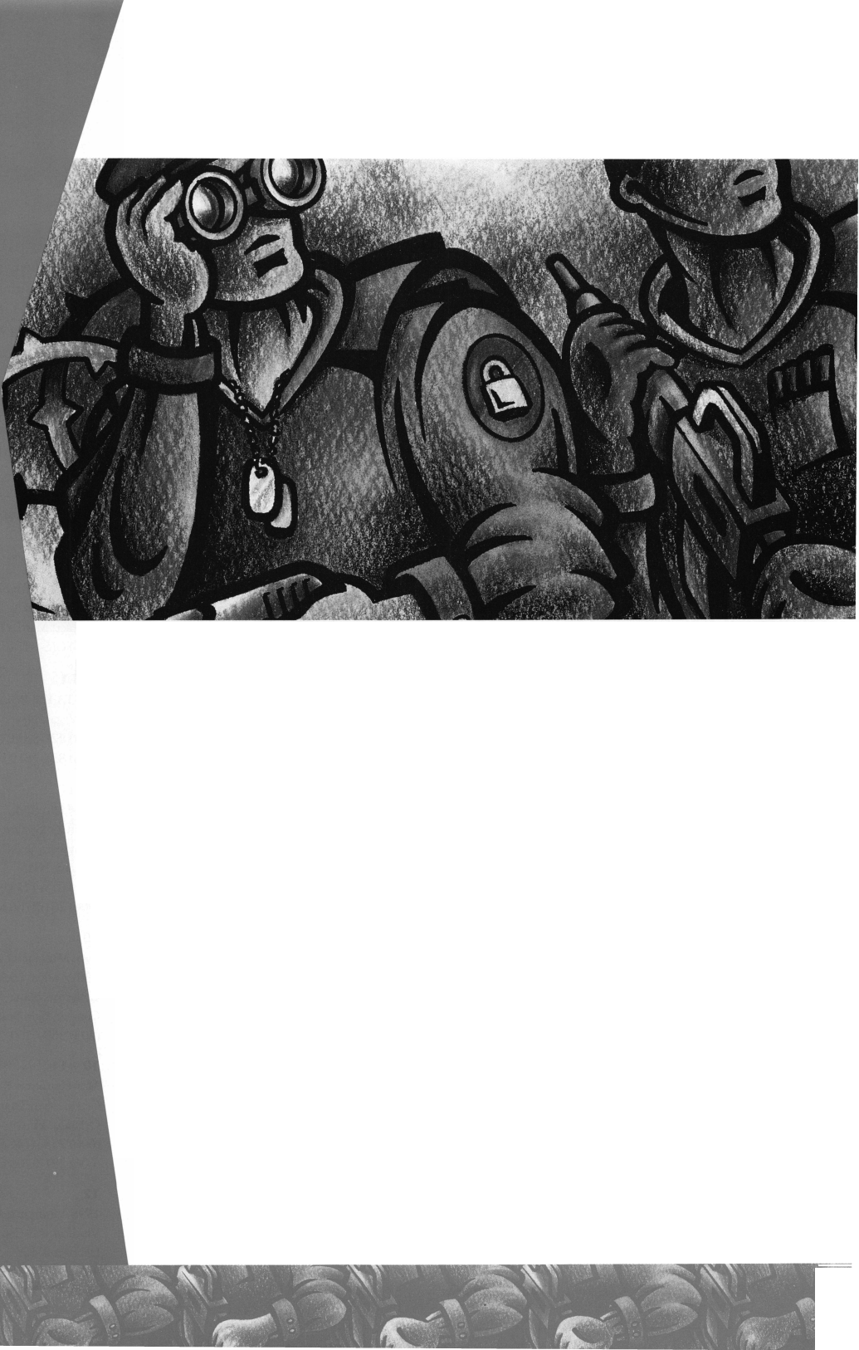

Upcoming

Events



Dept)

SEPTEMBER ’98 1-13

The Assoc, of Ontario Locksmiths Scarborough, Ontario (888) 272-8265

10-13

Greater Philadelphia Locksmith Association GPLA Annual Convention Philadelphia, Pa.

Contact: John C. Magee III (609) 845-3434

1. 845-3024

12

Mas-Hamilton,

Auditcon System 2100 Course Minneapolis, MN,

New Orleans, LA (606) 253-4744 ext. 180 (606) 281-5766 fax

12-13

Mas-Hamilton X-07 Certification/Troubleshooting San Diego, CA (606) 253-4744 ext. 180 (606) 281-5766 fax

13

**f** ALOA PRP SITTING Sponsor: GPLA Philadelphia, PA

Contact: William L. Young, CML

1. 647-5042 (610) 647-5950

14

1998 Vindicator and Vindicator II Course Lexington, KY (606) 253-4744 ext. 180 (606) 281-5766 fax

14-17

ASIS

44th Annual Seminar and Exhibits Dallas, TX (703) 519-6200 (703) 519-6299 fax

1. 20

Clark Security Products Southern California Trade Show Contact: Terri Burges (800) 854-2088, ext. 273

18

V ACE Class Clark Security Products Burbank, CA Contact: Terri Burgess (800) 854-2088, ext. 273

1. 20

Doyle Lock Supply, Inc.

Dealer Trade Show and Educational Weekend Contact: Paul M. Justen (800) 333-6953

1. 19

Door and Hardware Institute Creation of Education Foundation San Diego, CA Contact: Donna Munari (703) 222-2010 (703) 222-2410 fax

1. 20

Mark Bates Associates Combination Lock Technology II class Nicholasville, KY 40356-1850 Contact: Paula Bates (606) 887-0496 (606) 887-9491 fax

19-20

**\ ..** ACE Class

Alabama Locksmith Association Simplex/Unican Factory Certification/All-Lock Auto Update Contact: Jim Turner (334) 793-5080 (334) 671-1405 fax

19

1998 Vindicator and Vindicator II Course Lexington, KY (606) 253-4744 ext. 180 (606) 281-5766 fax

19

Mas-Hamilton,

Auditcon System 2100 Course Colorado Springs, CO,

San Francisco, CA (606) 253-4744 ext. 180 (606) 281-5766 fax

19-20

Ozark Professional Locksmith Assoc.

Fall Clinics and Get Away Weekend

Inn of the Ozarks

Eureka Springs, AR

Contact: Betty Gray

(501) 524-3660 day

(918) 427-1066 evening or

Bill or Janis Reeves

(501) 631-0017 day

(501) 631-6406 evening

20

**f/** ALOA PRP SITTING Sponsor: Doyle Lock Supply Plymouth, MN Contact: Paul M. Justen (612)521-6226 (612) 521-0166 fax

20

**&** ALOA PRP SITTING Sponsor: Clark Security Products Burbank, CA Contact: Terri Burges (800)854-2088

23-25

V-T. ACE Classes

Lou-Miss Locksmith Association

Jackson, Miss.

Contact: Thomas L. Hunt (205)833-3333 (205)836-3333 fax

25-26

Mas-Hamilton X-07 Certification/Troubleshooting Lexington, KY (606) 253-4744, ext. 180 (606) 281-5766 fax

26

ALOA PRP SITTING Sponsor: Lou-Miss Locksmith Assoc. Jackson, Miss.

Contact: Randy/Carolyn Benoit (504)447-8128

OCTOBER ’98

1-2

\__ POLA Trade Show ’98/

ALOA ACE Classes Penn Ohio-Locksmiths’

Association, Inc.

Independence, Ohio (Cleveland area)

Contact: Martha Eggler (216)575-2783 Fax(216)267-2511 e-mail: [PAL01l6@aol.com](mailto:PAL01l6@aol.com)

3

Mas-Hamilton,

Auditcon System 2100 Course Jacksonville, FL, New York, NY (606) 253-4744 ext. 180 (606) 281-5766 fax

4

San Francisco Bay Chapter of California Locksmiths Assoc.

Ninth Annual Locksmith Flea Market Hayward, CA Centennial Hall, Room 4 Contact: Lee Page (415)479-8879

4

**f/** ALOA PRP SITTING Sponsor: POLA Contact: Martha Eggler (216) 676-8464

8-1 1

SAVTA Fall Board Meeting Las Vegas, Nev.

(214) 827-SAFE (7233)

(214) 827-1810 fax

10

Mas-Hamilton,

Auditcon System 2100 Course Albuquerque, NM,

Lincoln, NB

(606) 253-4744 ext. 180 (606) 281-5766 fax

10

Lock Museum of America 26th Annual Lock Collectors Show Contact: Geri Stuttig (203) 869-6260

10-11

Mas-Hamilton X-07 Certification/Troubleshooting Orlando, FL

(606) 253-4744 ext. 180 (606) 281-5766 fax

12

1998 Vindicator and Vindicator II Course Lexington, KY (606) 253-4744 ext. 180

(606) 281-5766 fax

***Keynotes***

September 1998

15-18

MINK Convention/

ALOA ACE Classes Omaha, Nebraska Contact: Elmer Howard (402) 330-8701 (402) 330-9456 fax

17

Mark Bates Associates Combination Lock Technology III class Nicholasville, KY 40356-1850 Contact: Paula Bates (606) 887-0496 (606) 887-9491 fax

17

Mas-Hamilton,

Auditcon System 2100 Course Chicago, IL, Pittsburgh, PA (606) 253-4744 ext. 180 (606) 281-5766 fax

17

1998 Vindicator and Vindicator II Course Salt Lake City, UT (606) 253-4744 ext. 180 (606) 281-5766 fax

17-1 9

S. C. Association Meeting Columbia, S.C.

(803)735-1600

18

Mark Bates Associates Time Locks class Nicholasville, KY 40356-1850 Contact: Paula Bates (606) 887-0496 (606) 887-9491 fax

18

ALOA PRP SITTING Sponsor: MINK Locksmith Assoc. Omaha, NE Contact: Elmer Howard (402) 330-8701 (402) 330-9456

19-25

25 th Tri-Regional Locksmith Conference Portland, Ore.

Contact: Stan Hauer (503) 325-6003 phone/fax

21 -22

Mas-Hamilton X-07 Certification/Troubleshooting Portland, OR (606) 253-4744 ext. 180 (606) 281-5766 fax

21 -23

**\C** Yankee Security

Convention/ALOA ACE Classes

Providence, RI

Contact: Robert Mahoney

(800) 209-8266

(860) 646-2122 fax

23

**f/** ALOA PRP SITTING Sponsor: Tri Regional Convention Portland, OR Contact: John Kerr (503) 253-0424 (503) 520-9072 fax

24

Grand Canyon Chapter GM Airbag and V.A.T.S. class Bostrum High School Phoenix, AZ Contact: Robert Arthur (602) 848-0685

24

Mas-Hamilton,

Auditcon System 2100 Course Birmingham, PA; Dallas, TX (606) 253-4744 ext. 180 (606) 281-5766 fax

24

**f/** ALOA PRP SITTING Sponsor: Yankee Security Convention Providence, RI Contact: Robert Mahoney (800) 209-8266 (800) 646-2122 fax

29-30

Door and Hardware Institute Forum for the Future: Business Strategies for Electrified Products Orlando, FL Contact: Donna Munari (703) 222-2010 (703) 222-2410 fax

31 - Nov. 2

Door & Hardware Institute Annual Convention Orlando, Fla.

(703) 222-2010

Indicates ALOA ACE Class

Indicates PRP Sitting

NOVEMBER

8

**jP** ALOA PRP SITTING Sponsor: Ohio Valley Chapter Contact: Bob Sutton Dayton, Ohio (937) 836-6127

13-14

Door and Hardware Institute Creation of Education Foundation Dallas, TX

Contact: Donna Munari (703) 222-2010 (703) 222-2410 fax

18-20

Mark Bates Associates DoD/DoE Combination Locks class Nicholasville, KY 40356-1850 Contact: Paula Bates (606) 887-0496 (606) 887-9491 fax

21-22

Mark Bates Associates Professional Safe Drilling class Nicholasville, KY 40356-1850 Contact: Paula Bates (606) 887-0496 (606) 887-9491 fax

DECEMBER

5

Grand Canyon Chapter Annual Meeting and Banquet Wyndham Garden Hotel Tempe, AZ 85281 Contact: John Ilk, CRL (602) 921-0123 (602) 425-9566 (after 5 pm)

MAY

3-8

SAFETECH ‘99 Las Vegas, Nev.

Contact: (214) 827-7233 [www.mlanj.org](http://www.mlanj.org)

JULY

25-31

ALOA ’99 Security Expo Cincinnati, Ohio Contact: (214) 827-1701

2000 Date TBA

ALOA 2000 Las Vegas, Nev.

Contact: (214) 827-1701

APRIL

5-9

MLANJ 2000 Annual Convention Somerset, NJ Contact: (732)424-7827 [www.mlanj.org](http://www.mlanj.org)

MAY

5-10

SAFETECH 2000 Birmingham, Ala. Contact: (214) 827-7233

2001 MARCH 28 - April 9

MLANJ 2001 Annual Convention Somerset, NJ Contact: (732) 424-7827 [www.mlanj](http://www.mlanj) .org

1999

MARCH

12-14

IDN Hardware Sales, Inc.

Security Conference

Cleveland, Ohio 44122

Contact: Fred Strasberger, John Kress

or Bonnie Weston

(800) 521-0955

17-21

V-l... ACE Class

Sponsor: MLANJ Annual Convention

Somerset, NJ

Contact: (732) 424-7827

JULY

15-21

ALOA 2001 Security Expo Baltimore, Md.

Contact: (214) 827-1701

2002

JULY

21-27

ALOA 2002 Security Expo Rosemont, 111.

Contact: (214) 827-1701

September 1998

***Keynotes***

Applicants

For Membership

Dept

***The following applicants are scheduled for clearance as members of  
ALOA. The names are published for member review and comment prior to  
October 1, 1998, to ensure applicants meet standards of ALOA’s Code of  
Ethics. Protests, if any, should be addressed to the Membership Department  
and must be signed. Active Membership applicants (A) have worked in the  
industry two or more years. Allied Membership (AL) applicants are not  
locksmiths, but work in a security-related field. Apprentice Membership CAP)  
applicants have worked in the industry less than two years. A***

USA

ARMY EUROPE APO

028442, Todd L Howell, AP SPONSOR: Charles Robertson

ALABAMA

Birmingham

028438, Larry E Blackwell, A SPONSOR: Ronald Fowler 028365, Scott T Kervin, A SPONSOR: Mark Casey

Huntsville

028407, Wesely C White, A SPONSOR: Larry Warnick

ARKANSAS

Blytheville

028404, William Wheat, A

ARIZONA

Chandler

028416, Alfred Stevens, A

Glendale

028399, William J Kyslowsky, A SPONSOR: William Lee

Scottsdale

028428, Apollo Ellis, AP

Tempe

028373, Michael A Brennan, A SPONSOR: William Summers 028436, Tom Romaine, AP SPONSOR: John Ilk

CALIFORNIA

Bakersfield

028395, Sheila R Branquinbo, A

Long Beach

028376, Joseph W Contreras, AP SPONSOR: James Marshall

Moffett Field

028422, Christopher G Geary, A

San Rafael

028432, Mark B Carry, A SPONSOR: Leroy Page

CONNECTICUT

New Britain

028427, Gilbert F Thetreault, AP SPONSOR: Jon Griswold

DISTRICT OF COLUMBIA Washington

028369, Richard A Ashley, AP SPONSOR: Clarence Wiegel

FLORIDA

Gainesville

028413, Robert N Elmore, A SPONSOR: Jeffrey Kane 028414, Mike Lindsey, A SPONSOR: Jeffrey Kane

Naples

028397, Craig C Mackey, A SPONSOR: Norman Skinner

Palm Bay

028417, John Steckowich, A

GEORGIA

Atlanta

028437, Judi Banks, A

Columbus

028435, Harold S Vaughn, A

McDonough

028434, Edward D Hanes, A SPONSOR: A1 Morris

ILLINOIS

Batchtown

028374, Everett E Friedel, A SPONSOR: Michael Edwards

Berwyn

028375, David J Chmelina, A

Decatur

028441, Donald K Martin, AP SPONSOR: Joseph Schuerman

Lake Zurich

028419, Kenneth C May, AP

INDIANA

Greencastle

028443, Richard W Newnam, A

KENTUCKY

Winchester

028423, Jason B Randall, A

MARYLAND

Baltimore

028440, Charlene F Bennett, A SPONSOR: Michael Jordan

Conowingo

028410, Stephen D Stanley, AP

Frederick

028439, Robert F Mangine, A

MINNESOTA

Blaine

028367, Todd C Meyhoff, AL SPONSOR: A1 Ernst

MISSOURI

St. Louis

028411, Robert L Theobald, A SPONSOR: Michael Edwards

MISSISSIPPI

Senatobia

028447, Joanne S McGee, A SPONSOR: Charles Payne

NORTH CAROLINA Mooresville

028445, Ron Pierantoni, AP

NORTH DAKOTA Fargo

028433, Gary L Grandbois, AP SPONSOR: Gregory Dwyer

NEW JERSEY Edison

028366, Carrion Geno, A

Pitman

028405, Brian D Ulrich, A

NEVADA Las Vegas

028396, Kevin W Forcade, AL

NEW YORK Bohemia

028429, Michael Festa, A SPONSOR: Edward Povinelli

New York

028398, Otto E Gonzalez, A 028381, Marik Peker, A

Staten Island

028420, Alan E Grym, A 028421, Michael K Shanahan, A

OHIO

Columbus

028389, James L Holbrook, A SPONSOR: Charles OBrien

OKLAHOMA

Ardmore

028446, Joe R Genn, A

Norman

028403, Don E Holzberein, A SPONSOR: James Holzberlein 028402, Danny L Morgan, A SPONSOR: James Holzberlein 028401, Cecil R Parker, A

PENNSYLVANIA

Philadelphia

028418, George A Manire, AP SPONSOR: Joe Lee

West Pittston

028368, Ted J Hughes, A

PUERTO RICO Guaynabo

028380, Jorge L Baeze, A

TENNESSEE

Cookeville

028426, Randy Gentry, AP SPONSOR: Ernest Langley

LaVergne

028388, Thomas C Sherwood, A SPONSOR: Samuel Miller

Madison

028387, Cordell K Smith, A

Memphis

028385, Jerry Pardue, A SPONSOR: Charles Payne

Nashville

028430, Gary L Parker, A SPONSOR: Beverley Penney

TEXAS

Dallas

028393, Joseph Nardozza, A SPONSOR: Melissa Sibley

028379, Warren W Stephens, AP

El Paso

028382, James R Williams, AP

Lubbock

028371, James L Latch, AP SPONSOR: Alton Sprawls

UTAH

Brigham City

028400, Michael A Jenson, A

WASHINGTON Bonny Lake

028370, Michael T Buman, A SPONSOR: Gordon Buman

WEST VIRGINIA Princeton

028364, Brian D Wiley, AL

WYOMING

Riverton

028412, Larry C Johnson, A

ARGENTINA

85 AS.

028391, Sergio W Prieto, A SPONSOR: Evelyn Wersonick

AUSTRALIA

Yadeoville NSW

028431, George B Wooll, A SPONSOR: George Ramsay

COSTA RICA

San Jose

028386, Marco Hernandez, A SPONSOR: Shirley Schamp

ENGLAND

Bristol

028394, Samuel L Allen, A SPONSOR: Tony Mendes

OXFORDSHIRE

Wallingford

028444, Aidan C Shoebridge, A SPONSOR: Paul Souber

SPAIN

Gijon Asturias

028390, Sampedro J Garcia, A SPONSOR: Steve Gallagher

HONG KONG

Shatin

028406, Wong S Siu-Shing, AP SPONSOR: Kwok-kei Leung 028409, Wing-Fat Lau, A SPONSOR: Kwok-kei Leung

JAPAN

Akita City

028377, Yoshihito Kagaya, A SPONSOR: Kazuhisa Matsunaga

Fukuoka

028450, Shinji Yano, A SPONSOR: Yoshitomo Harada

Hiroshima

028425, Veno Hiroki, A SPONSOR: Takeshi Kato

Ichikawa-City Chiba

028363, Zenzaburo Takano, A SPONSOR: Toshihiro Asano

Kashiwa-City Chiba

028361, Jun Yamazaki, A SPONSOR: Toshihiro Asano

Kitakyushu-City

028378, Satoru Horiuchi, A SPONSOR: Yoshitomo Harada

Oitashi

028408, Tetsuo M Katayama, A SPONSOR: Yuriko Yanai

Shibuya-Ku, Tokyo

028424, Uzuki Fumihiko, A SPONSOR: Yoshizawa Makoto

Tokyo

028384, Wake Noboru, A SPONSOR: John Elliott

OSAKA

Higashiosaka

028449, Yoshio Mizutani, AL SPONSOR: Yuriko Yanai

NEW ZEALAND

Invercorgill

028415, Gary P Rewcastle, A

Manukau City

028372, David R Nicholson, A SPONSOR: Kenneth Lees

URUGUAY

Montevideo

028392, Alfredo P Bianchi, A SPONSOR: Kenneth Griffin

September 1998

**J** Keynotes



ASSOCIATED LOCKSMITHS OF AMERICA, INC.  
MEMBERSHIP APPLICATION

Welcome to the Associated Locksmiths of America, Inc., an association for persons involved in the security industry as locksmiths, security consultants, educators, manufacturers, or distributors.

To apply for membership, please complete this application and submit it with the application fee, dues for the current year, and your business card, company letterhead, or suitable proof of employment.

All of the following questions MUST be answered before this application may be processed: (Please Print)

PERSONAL INFORMATION

Mr. Mrs. Ms. (circle one)

Business Mailing Address Home/Other Mailing Address

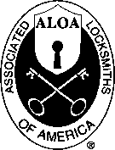

|  |  |  |  |  |
| --- | --- | --- | --- | --- |
| (Last Name) (First) | pdHIi] |  |  |  |
| Business Name |  | Address-Street and Number |  |  |
| Mailing Address-Street and Number |  | City and State |  | Zip Code |
| City State | Zip Code | Phone | FAX |  |

Phone FAX Social Security No. Date of Birth

Mail: Bus.D Home D Directory Listing: Bus. Q Home □ NoneD

PROFESSIONAL INFORMATION

Are you a sole owner?, Partner, Corp. officer, Employee, Student?

Are you currently engaged in the security industry? Yes No If yes, how long?

What percent of your work time is spent in locksmithing?

How did you learn locksmithing or security work?

Are you a member of a local locksmith association? Yes No If yes, please provide name, city, and

state of association(s):

ALOA Member sponsor ALOA #

Please note: If you are sponsored by an ALOA member, your application will be immediately processed with a 90-day probation period. Otherwise, final processing will take 120 days.

Give names and addresses of two industry-related references (required):

1

2:

TYPES OF MEMBERSHIP -- Please check only one:

O ACTIVE MEMBERSHIP -- Individuals actively engaged in supplying, servicing, or installing security hardware for a period of not less than two years.

Q APPRENTICE MEMBERSHIP -- Individuals who are in initial training and meet all the requirements for Active Membership except for length of time in the security industry.

Q ALLIED MEMBERSHIP -- Individuals whose position in the security industry relates to the aims, policies and promotion of the locksmith and his or her craft.

2/27/97

APPLICATION AND FEES

A $40 application fee, appropriate annual dues, and your business card, company letterhead or suitable proof of employment must accompany this application.

ANNUAL DUES: ACTIVE/ALLIED MEMBER SI 25 APPRENTICE MEMBER *75

• Dues include $25 subscription to monthly magazine. **Keynotes**

NOTE: Your second year's dues will be prorated based on the date your application was received by ALOA.

Have you ever been convicted of a felony? Yes No

If yes, please give details on a separate sheet. All felonies are reported to the Membership Committee for review.

I certHy that all statements are true and If accepted as a member, I agree to abide by the rales, relations, and Bylaws of ALOA and further agree to adopt the Code of Ethics of ALOA as mgr own and adhere to it to the best Of my ability. Should my membership be discontinued, I agree to nSDira nqr mwnbership card and cease use of all ALOA insignia.

Signature **'** **■ ‘** Dat**e** **... ■ . : ■**

METHOD OF PAYMENT

* CHECK (Payable to ALOA in US funds)
* CREDIT CARD

□ American Express □ VISA □ MasterCard □ Discover Card Number Expiration Date

Please print name as appears on card

Cardholder Signature

FINAL CHECKLIST!

O $40 Application Fee

* $125 Active/Allied Membership dues □ Letterhead or Business

O $75 Apprentice Membership dues Card or Proof of

O $15.40 for Canadian Air Mail Employment

* $37.40 for Overseas Air Mail

TOTAL ENCLOSED $

Return to: Associated Locksmiths of America, Inc.

3003 Live Oak Street; Dallas, TX 75204 Phone: (214) 827-1701; FAX (214) 827-1810

|  |  |
| --- | --- |
| Received $ | For office use only  Number |
| Appl. Fee | Dues Date Rec'd. |
| Bv | Date App'd. |
| Apprentice transfer | Applicant listed |
| in Kevnotes | |

**November 6-8,1998  
Well Be There. Will You?**



**ROFU**

**WHOLESALE**

SARGENT®

*First in quality since 1864*

**Defiant Safe Co.**

**LOCK *DISTRIBUTORS***

Graffunder

**C©3 ^ Sa& & Vau^ Co>**

Marray Enterprises

RENO - NV. '98

**at the**

**Reno Hilton Reno Nevada**

**StrongArm, Inc.**

! R.R BOXMAN

I & ASSOCIATES. INC.

1 Rarker Hardware

**Don Carnie Associates**

**Master Lock**

**CALL KATHY AT (847) 692-5940**

**AND REGISTER TODAY!**

m



*UJftLCICJf SUPPL Y*

EZZllSeturity <^tm medeco®#

SECURITY LOCKS, INC.

**SIERRA PACIFIC**

**VONDUPRIN**

**Part of worldwide Ingersoll-Rand**

**FORT LOCK CORR**

***JIM DANIELS***

*SALES*

worldwide coverage

A|5jSjSrP

car locks & lock parts

K

Ljk



Dor-O-Matic

*LOCKNETICS*

*ii in*



*EBB*

FIM06RHV THE *ACCESS CONTROL!*

**/instate**

**maha Intellikey**

**HOLESALE**

**ARDWARE**

*THE LEADER IN THE ACCESS CONTROL TECHNOLOGY f* m^TCH

Howard Sales

CLARK Company \ '

SECURITY PRODUCTS

**MONARCH HARDWARE**

ww

**DORMA**

**Yale®**

**YALE SECURITY INC.**

*itnn*

**GLYNN-JOHNSON**

**INGERSOLL-RAND**

**ARCHITECTURAL HARDWARE**

**Security Hardware**

]

**IHAYMANI**

I QUALITY BUILT SAFES I

<o

***Chicago\***

EMKini EV.®

9imrbEA^

ACCESS CONTROLS

***j***

uwv retHCiO^FCfi ihe gtst«NW



*Automotive* - *Alabama*



**ACCISS I UklWAU SsiPH.Y**

**NATIONAL** (HD **CABINET LOCKI**

*DLR SALES,*

*INC.*

**Olympus**

LOCK inc.

**H.E. MITCHELL, COMPANY**

HANCHETT ENTRY SYSTEMS. INC  
Manufacturing Products for  
Access Control



BWD

0 **AMSEC**

^3 Major

Tj V uanufacturing. inc.

**C**

|  |  |
| --- | --- |
|  |  |
| fcVllfcM | il  m. |

**oX k? F l(o)»ro iMC**

**CO**

*SECURITY INNOVATIONS*

PROPRIETARY CONTROLS

systems corporation FALCON HARDWARE

kuiik/et

**PCSC**

**Norton**

**SCHLAGE**

**YALE SECURITY INC.**

Part of worldwide Ingersoll-Rand

DDA.I Al# wr itv kvri

**II A L A X**

I SB C .

**LOW TECH PRODUCTS**

RSpnimpc

Hi 1. HARDWARE & LOCKSMITH SUPPLIES

IS



m

**ACCESS HARDWARE SUES. INC.**

Reader Service #2

NATIONAL GUARD  
PRODUCTS

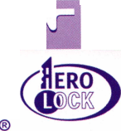

core

•PowerLever to the People

Taking “Best of Show” and “Best New Product in Door Locks” at ALOA ’98’s New Product Awards was Mas Hamilton’s PowerLever.

Employing all of the things that made their safe locks a success, Mas Hamilton applied the same technology to their newest door product.

“PowerLever is a self-powered access control door lock that also provides audit capability,” says John D. Brown, Mas Hamilton’s vice president of Sales and Marketing. “Many products in the marketplace usually use batteries or are hardwired. Depending on who you talk to, you’ll hear estimates that range from $1,000 to $4,000 a door in order to

tions. It was also reviewed in the June/July edition of Keynotes. This month, however, PowerLever will be put to the ultimate test as it officially hits the market.

“The response that we’ve gotten from the potential customers, resellers and distributors has been simply overwhelming,” Brown says. “Basically, there is a tremendous number of businesses who have an application for this type of lock. We think that this product will have significant impact on the marketplace particularly in areas where a small business doesn’t want to invest in expensive hardware access control system. Even in bigger businesses where they have individual doors

“We think that this product will

have significant impact on

marketplace particularly in areas

where a small business d

want to invest in expensive  
hardware access control system.”

hardwire a door. And with batteries, you have the obvious problem of the batteries going dead at the absolute worst time. With PowerLever, one crank of the handle provides all of the power needed to operate the lock.”

According to Brown, the user can then key in their personal identification number and providing they’re on the user list, they’ll gain access. Aside from that, it keeps an audit trail showing who’s entered at specific times.

“The applications are plentiful,” says Brown. “They can range from airports to hospitals to hotels, but it’s mainly designed as a battery and hardwire-free access control system.”

PowerLever has been making the rounds at various trade shows, conferences and conven-

they want to protect and don’t want to go through hardwiring. Thus far, all of the customers who are testing PowerLever are by and large very enthusiastic about it.”

• Mike Emery

•ALOA election update

The list of candidates for the fall ALOA board of directors election was not complete at press time. Members will be kept informed through Keynotes, the ALOA web page ([www.aloa.org](http://www.aloa.org)) and the mail about both the eligible candidates and the next step in the election process. Stay tuned!

September 1998

**' 2 I** Keynotes

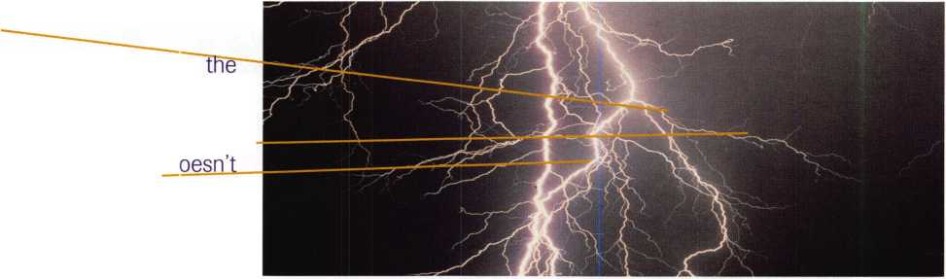

•Remote Patrol

In their continuing efforts to advance the state of safe security, Sargent & Greenleaf came up as winners at ALOA ’98s New Product Awards. Earning honors for “Best New Product in Safes” was S&G’s Comptronic technology.

As the name indicates, the application is the union of computer technology and electronics. Both are utilized towards a line of safe locks that the company feels will enhance effectiveness and convenience.

“Historically, Sargent and Greenleaf has produced and designed mechanical combina­tion locks,” says Thomas J. Leppert, Sr., vice president of Marketing and Sales.

“Comptronics is the trademark name we’ve given to our electronic combination locks. There are several models within the family from the 6120 up to a 6140. Each has different features and is used in different applications.”

Where standard mechanical locks were limited to letting someone in and out of a safe, Comptronic locks are able to integrate with other monitoring systems to enable users better control over safes, vaults, ATMs,



Black and Decker has agreed to  
sell Emhart Glass to Bucher  
Holding of Switzerland ...Dedicated  
Micros has received their ISO 9002  
certification... ISC Chicago reported  
attendance of 1,822 with 200 companies  
exhibiting... Napco Security Group  
has opened a new warehouse in Las  
Vegas that will stock all of Napco and  
Alarm Lock’s products Security  
Lock received the Leadership Award  
from Hanchett Entry Systems for  
having the largest sales record...SPX  
Corporation, a manufacturer of  
vehicle components, has reached an  
agreement to acquire General Signal  
Corporation, a manufacturer of  
electrical control products.

and other designated areas. They also monitor when a safe was accessed and by who, and give authorized persons the power to quickly change combinations when necessary. In addition to these and numerous other convenience factors, Comptronic locks are able to transmit a silent alarm from the actual lock to central security.

“These locks cover a wide range of what we call ‘cash or asset containers.’ These can be drawers, file cabinets, vault doors, vault rooms, and others,” Leppert says. “We have in the field, applications where the central teller can control different teller drawers. A senior teller doesn’t have to get up from his or her station to open another teller’s drawer. Now, this can be done remotely. We’ve also eliminated false alarms. There’s a module that disables the alarm when the lock is open and arms it when the safe door is closed. This saves merchants and financial institution lots of money in fines and or losses. The applications are endless. It’s kind of like the game show ‘Jeopardy.’ With these products, we have a lot of answers. All we need is a lot of questions.”

• Mike Emery

•execs

ADI has named Peter Bothello

director of Product Management for Burglar Alarm and Sound and Communications Products. ...

Dedicated Micros has named a new CEO, Thomas E. Cashman....

Curtis Industries, Inc. named A. Keith Drewett president and chief executive officer and Idelle K. Wolf executive vice president and chief operating officer. ... Kaba High Security Locks, has just appointed Rick Eisen as eastern Regional Sales manager. ...

Jim Somerville is now serving as Sales manager for ADI’s newly acquired Northern California locations. ...

•Great News for Texas Locksmiths!

The Texas Board of Private Investigators and Private Security Agencies (“Agency”) has agreed to enforce alarm licensing for electronic security devices only when they are tied to a monitoring company. As many of you know, under the original alarm licensing law, locksmiths who did not install detection devices were exempted. Then in 1995, the law was amended to take out that exemption, and through a broad definition of “detection devices,” brought electronic security under alarm licensing (see Keynotes June/July issue).

On June 22,1998, Jay Kimbrough, Executive Director for the Agency released the following administrative memorandum:

“Please be advised that this agency will interpret and apply the term ‘detection devices’ as contained in Tex. Rev. Civ. Stat. Art. 4413 (29bb) §2(33) as encompassing those electronic devices that are being used or will be used as part of a burglar or hold-up alarm system (which the Board, in turn, interprets to be systems monitored for input from such devices on a current or real-time basis and would include systems primarily designed to prevent or detect intrusion which are regularly or peri­odically checked by a monitoring company to determine if there has been an intrusion), provided that any entity, agent or officer licensed and regulated by this agency on or before July 1, 1998 shall not be affected by this administrative memorandum.”

Many people are to be thanked for this outcome, especially Don Bradford of Fairway Supply, Mike Groover of IDN-Acme, Inc., Howard H. Johnsen of the Hans Johnsen Company and Bill Power of American Security Distribution. However, we are not out of the woods yet. To make this change permanent, legislative action will have to be taken in 1999- ALOA urges you to support the Texas Locksmith Association (TLA), and all that their lobbyist is doing for locksmiths in the Lone Star state. But for today, we can proclaim VICTORY!!!

September 1998

Keynotes

core

**spotlight news**

•prp

CMLs

Roger C. Yost, Logan, UT

CPLs

Roger G. Gant, Saltillo, TN Kenneth D. Nutt, Evansville, IN

CRLs

Howard K. Abraham, Miami, FL

James Ashley, Kennersville, NC

Anthony E. Bishop, Vienna, VA

Richard C. Cook, Rigby, ID

Vincent Deangelis, S. Haven, MI

Diane Foto, New Orleans, LA

Thomas Gillingham, Jr., Antioch, TN

Warren Grams, Mesa, AZ

Ronald Harrison, Lebanon, TN

Robert D. Hendricksen, West Richland, WA

Lee G. Holcomb, Carriere, MS

Travis S. Holcomb, Sophia, NC

Kenneth A. Makepeace, Holland, MI

Thomas J. McCausland, Westchester, PA

Doug Martin, Canton, MO

David Morris, Knoxville, TN

Lee Most, San Francisco, CA

Tony R. Parsons, High Point, NC

Francisco Rico, Miami, FL

Ernest L. Robinson, Auburn, WA

Jerrilyn H. Robinson, Dalton, GA

Daniel G. Simson, Oak Ridge, NC

Charles D. Stone, Orlando, FL

Bruce Tinsley, Mesa, AZ



•obituaries

ALOA recently bid a last farewell to the following industry professionals:

Paul Kahley, aged 69 who was integral in the success of Pauls Lock Service.

26 year member, Earl Ames, aged 79, an inspiration to Ames Locksmith Company.

Paul Cyphers, aged 54, an ALOA member since 1983 and a principal figure at Cyphers Lock and Key.

William Hoffman, aged 63 who had been an ALOA member since 1971.

The founder of Allsafe Company, Inc. Edwin L Pokornowski, aged 68.

41 year member, Franklin Wanner, aged 83, who had run his own locksmith service.

Howard Smith, aged 87 and an ALOA member since 1956.

G. Pressley Rhodes, aged 58 who owned and operated Georgia Lock and Safe and AAA Lock and Key in Augusta, GA.



•ASSA ABLOY acquires Securitron Magnalock

ASSA ABLOY has gained new ground in the area of electric locks. With its acquisition of Securitron Magnalock, the leading U.S. manufacturer of magnetic locks, ASSA will no doubt capitalize on the Reno, Nev.-based company’s expertise and experience with these kinds of products.

President and CEO of ASSA’s Connecticut-based operations, Clas Thelin is most optimistic about the union and says that it will strengthen both companies.

“They are a good addition to the group,” he says. “They have great products within an area that I believe will grow. Products like mag-locks, strikes and similar products. It’s definitely an interesting area that we plan to get more and more into. Trends will always lean towards higher security. Electro-mechanical products and electronics will continually play bigger and bigger roles, and we believe that ASSA has a product that will complement what Securitron is putting out.”

The addition of Securitron follows the recent acquisition of Medeco just a few months ago. Aside from giving ASSA ABLOY a competitive edge in the realm of electric locking, it should also prove to be an asset in distribution.

“They’ve been very successful in this area,” Thelin says. “This means that they have distribution channels that were not active with us before and that also provides an interesting potential for us.”

According to Securitron’s president and CEO, Bob Cook, the deal will have positive effects on both companies and not have any drastic bearing on Securitron’s Reno operations.

“It is ASSA’s intention to operate us independently leaving us right where we are,” he says. “But they will broaden the sales channels in two ways. ASSA owns a number of other companies that have a stronger marketing presence in professional hardware channels. These companies supply electronic products into those channels. Therefore, we can be a supplier through these other ASSA ABLOY companies. The products that we manufacture will be available through some of those companies who have their own channels where we’re not very strong. Vice versa, some of the products manufactured by those companies will go through our channels where they’re not very strong. It’s just a better way to get all of the products out to the highest number of potential customers”

• Mike Emery

Keynotes

September 1998

**by Tim** McMullen

Many of you already know that ALOA tracks legislation, and notifies members of pending bills that could affect their business.

But many of you may not know that the resources we use to keep you abreast of what’s going on is AVAILABLE TO YOU TOO. The following are the legislative resources provided by ALOA:

STATERACKThis is ALOA’s legislative monitoring service. We can sign on to this everyday via the computer, and type in a few keywords like “alarm,” “locksmith,” “electrician,” “electronic security,” and immediately bring up any bills or regulations that were introduced that affect our industry. Heard a rumor that a bill was introduced? Call us and find out for sure!

STATE YELLOW BOOK This quarterly-updated resource has phone and fax numbers for every state representative, state senator, committee chair, listing of committee members, and everyone in the executive or judicial branch of state government. If you need a number, just call!

STATE LEGISLATIVE SOURCEBOOK This handy little

guide has every state agency listing, media service, news service, state lobbyist etc. Again, if you need a number, just call!

INTERNET SITES OF STATE LEGISLATORS We’ve

“bookmarked” on our internet browser every state web site, including every legislature’s homepage. This allows us to look up text of bills, committee agendas, and even contact legislators via e-mail. A copy of all state web sites can be faxed to you instantly!

MODEL LAWS Need a copy of any state law? We’ve got ‘em! We’ve also written up summaries of many of the laws that effect locksmiths or the access control industry. Even ALOA has a model law you can use.

ALOA SITE WITH LINKS As you know, legislative material is already on the ALOA web site. What you may not realize is that we administer this homepage right from the office. What this means to you, is that we can post any urgent legislative information you give us, at any time.

INDUSTRY MEMBERSHIPS To help keep the “pulse” of the security industry, ALOA is involved in many other organizations and coalitions including the State Government Affairs Council, Low- Voltage Systems Alliance, SIA Government Relations Committee, and the Consortium for Home & Building Systems Training. If you are interested in being copied on any minutes, just let us know!

BLAST FAX SYSTEM Soon, through ALOA’s “blast fax” and “fax on demand” capabilities, we can immediately fax updates in a timely manner, and notify members of legislation affecting them in their state within minutes of a bill’s introduction.

LEGISLATIVE UPDATE

ALABAMA (Regulations) The Alabama Electronic Security Licensing Board has agreed to interpret “access control”—unless it involves alarm monitoring—as not covered by the new law.

TEXAS (Regulations) After months of negotiating, a compromise settlement agreement was signed by the Texas Private Board of Private Investigators and Private Security Agencies that oversees the licensing of security systems. The term “detection devices” will now be tied only to those systems that are regularly or periodically checked by a monitoring company (see related story on page 13).

ILLINOIS SB 1251 Exempts locksmiths who apply for an alarm license between September 1, 1998 and September 15, 1998 from having to take an alarm examination (i.e. extension of the grandfathering provision). Locksmiths who apply between September 1, 1998 and September 30, 1998 for a locksmith license will also be exempted from taking a test. Applicants must still meet all other requirements for licensure under the Act. Signed by Governor on 6/26/98.

NEW YORK AB 11425 This bill was introduced August 21, 1998 and was referred to the Committee on Consumer Affairs and Protection. It requires locksmiths to obtain identification from a person requesting the performance of an opening of residential or commercial premises, safes, vaults, and motor vehicles. A locksmith will be required to keep records and to provide access to such records to law enforcement officers.

**Are You A  
BWD Certified  
VATSmith?**

**Wanna Be?**

Locks Kits Training Certification

For a FREE VATSmith information packet and  
locations of BWD Certified VATS Centers

800-647-4926

See us at [www.alllock.com](http://www.alllock.com)

Reader Service #3

September 1998

***Keynotes* ^3**

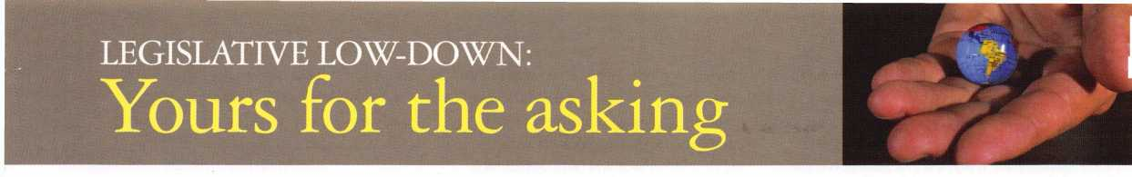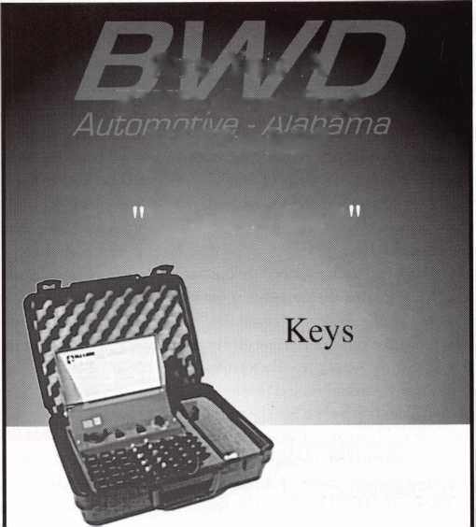

E

ach year when Crime Prevention Month  
rolls around, I pretty much expect the  
same type of expert that I’ve always seen  
represented on radio or television.

Usually you’ll find a crime prevention officer from some police department or similar government agency The other common expert is a representative from the alarm industry. Often you’ll also see a security consultant of some kind with knowledge about terrorism or violent crime such as armed robbery or assault.

I have personally never listened to or watched a program with a locksmith on such a panel, but I know in rare cases locksmiths have appeared on such programs.

I have often wondered (maybe as some of you) why our profession is so rarely repre­sented as knowledgeable or expert when it comes to securing one’s home, business or personal safety. I have a few personal theories about it. First of all, I think (as a professional group) that we are less well organized than the groups more commonly consulted on such

when it comes to physical security. Hit and miss efforts with inconsistent and sometimes conflicting messages might very well be worse than no communication with the public at all. Unprepared and unknowledgeable representatives of our industry can be cut to ribbons by a media tendency to find entertainment value in making fools of or embarrassing the people interviewed. First impressions provided by an ignorant locksmith can tar the entire profession.

As a rule, we don’t have the same media contacts or media savvy as other industries. That is something that can be remedied by time and effort, but a message must exist before it can be presented. A boat won’t get anywhere unless most (if not all) the oars are rowing in the same direction. What that means is that a large percentage of locksmiths must believe that working together is essential. But even more so, there must be open-minded attitudes to acknowledge the need for educating ourselves, and the ability to

company of those experts, hold other pieces of the puzzle. If we all do our homework, we and those experts should be able to construct that puzzle and give the general public a reliable explanation on how to secure themselves and their property.

To solve the puzzle, we need reliable sources of information. The question is,

“where do you find them?” You can find infor­mation anywhere. “Reliable” information is something else. Most of us have dealt with insurance agents at one time or another. We rely on their knowledge and integrity so that we don’t buy way more insurance than we need or not enough to cover our actual risks.

A clever insurance agent might be able to sell hurricane insurance to a farmer in Kansas, but a policy that covered tornadoes might be more suitable (just ask Dorothy and Toto). Selling the proper coverage to a client will earn the insurance agent an honest profit, and it will engender trust so that the same client will be glad to call on the agent in the future. But

rminn

Crime Prevention ExpertsP,

programs. A large percentage of us are very independent minded when it comes to working with or cooperating other security professionals. Some of us think we know everything, so being part of an organization seems unnecessary and a waste of time.

Others have had bad experiences with one or more associations and have written them off as worthless.

Even large and well-organized groups have a tough time getting their message across to the general public. Trying to buy all the media time (that is needed to properly explain the kind of work and service that a profession provides) can be an endless and fruitless financial drain. It is necessary to be consulted on news or public affairs programs to give extra legitimacy to your message. While this is often free media exposure, it is necessary to have knowledgeable and presentable represen­tatives to give a clear and consistent message.

Imagine an organization in the state of chaos or flux trying to communicate effec­tively with the public. There’s not much to imagine. It just doesn’t happen. I know individual locksmiths here and there have made a serious effort to portray a professional locksmith as one of the experts to consult

toss aside preconceived notions to accept properly investigated and researched informa­tion that honestly tells us what actually will improve the security of our clients. That involves having both technical skills and wide product knowledge. It is a lot to ask from a large group of people with vastly differing opinions. I have no idea whether it is probable or even possible.

Cooperation is something that is very difficult to predict, so I won’t even try.

Instead, I will try to explore where we might be able to look for the information we need, if we are able to cooperate and work for a common cause.

Where Do You Find Reliable Information?

I started out asking, “Who are the crime prevention experts?” and didn’t really answer the question. I indicated who were perceived to be experts. Reality and perception are sometimes the same, but they are often different. Now I’m not indicating that those examples of experts are necessarily wrong, but they are incomplete. Physical security and crime prevention are a puzzle, and those “experts” hold pieces of the puzzle. Locksmiths, who are rarely included in the

even the most honest insurance agent must rely on the research done in his industry about the varied risks there are in life and who will likely face those risks.

As experts in physical security, we find ourselves in the same boat. We can quote statistics left and right, but if we don’t know which risks apply to which customers, we will overprotect some and under protect others.

It would seem that our best source of reliable information would be government crime statistics. It is my opinion that such information is much less useful than we might otherwise think. I believe that we need two categories of information: 1) very broad general information and 2) narrowly focused and targeted information by region and person classifications. As with insurance where it can’t be predicted with absolute precision who will suffer which losses, we don’t know which thief will break into which house and with what method. Otherwise, some of us could safely go without fire insurance for our homes or choose not to lock our doors at night.

There are some general risks that are so common that it is not safe to go without, even though the majority of us will never be victims. Standard insurance packages would

-A

Keynotes

September 1998

apply as would ordinary security locks. There are unique circumstances where only specific knowledge and probing questions will find the correct solution for insurance coverage or security products and services. It would be extremely expensive and time consuming if every insurance agent decided to do his/her own research, when so much information overlaps. There is justification for pooling resources and paying a small amount (among large numbers of individuals) each to have a designated institution do the work. Insurance and other industries have such institutions, we unfortunately do not.

Our industry needs to reach out to others to pool resources when we have common concerns and information needs. The crime prevention units of police departments would probably be more effective and informative if they could share our perspectives on security hardware. And we could surely benefit by knowing accurately what criminals are doing. What circumstances actually deter them and what devices reliably stop them? How much is enough to stop a burglar and when do you reach the level of security overkill?

It is never in the interest of any industry to cheat the public to make their profit, when they can make the same profit or more by providing the public with what it actually needs. That means we have to be smart and look long term. If we provide quality product and services to our customers, we can look forward to more than just a comfortable living. We can look at ourselves in the mirror and know we are making an honest living too.

I don’t know how many of the options that I will suggest are practical or even possible. Business, at times, seems to be more cutthroat than in the near past. I don’t know if coopera­tion would be extended back by those other industries, however, these are my suggestions.

Architecture and Construction

Crime rates are high. Why isn’t security being designed into the structure and design of buildings, along with the aesthetics? Can our input help them in that direction and will that make it easier for us to secure homes and businesses?

Insurance

They measure and insure risks. It is our job to try and minimize or remove risks. Can their statistics and information help us focus on where our future customers will be and what their needs will be? Can our work in improving security help them reduce insurance rates to their customers and reduce their risk and expense?

Law Enforcement

Why don’t we cooperate more? Should we be fighting over who should be opening cars, or maybe we could work together to improve the physical security of homes and businesses? What information can they share with us to make our job easier and how can we do the same for them?

Alamt Industry

Why are we trying to scratch out each others eyes, when we each have different areas of expertise in a very large and profitable security market? Neither industry should be

trying to put unreasonable restrictions on the other in order to kill it.

I don’t live in a fantasy land, and I’m not naive enough to think that writing something down will actually make it happen. I’m sure there are many more (and much better) suggestions on how to make our industry better. I’m not holding my breath for any of this to happen. I’m not even sure that we can cooperate among ourselves. But as they say, “nothing ventured, nothing gained.” Well, that’s just my two cents.

Reader Service #4

*ite inesdc*

***Single Door Controller By* medeco**

**A Breakthrough Single Door Electron­ic Access System from the name you trust for high security locks.**

**Throw away those keypads! Now you can have the simplicity and low cost of a key­pad with the versatility and power of a hard-wired system.**

**Benefits of the SiteLine SDC System:**

* **Stand Alone Operation**
* **Affordable**
* **Unique Portable Database Keys**
* **TVue Dual-Technology Credential w**I **Mechanical blank and Electronic keyhead**
* **Intuitive Windows® 95 Software**

ALOA 1998

People's Choice Award

Best New Product

HIGH SECURITY LOCKS

*©1998 Medeco Security Locks Inc.*

**For more information call Customer Service toll free at** 1-800-839-3157

September 1998

Keynotes

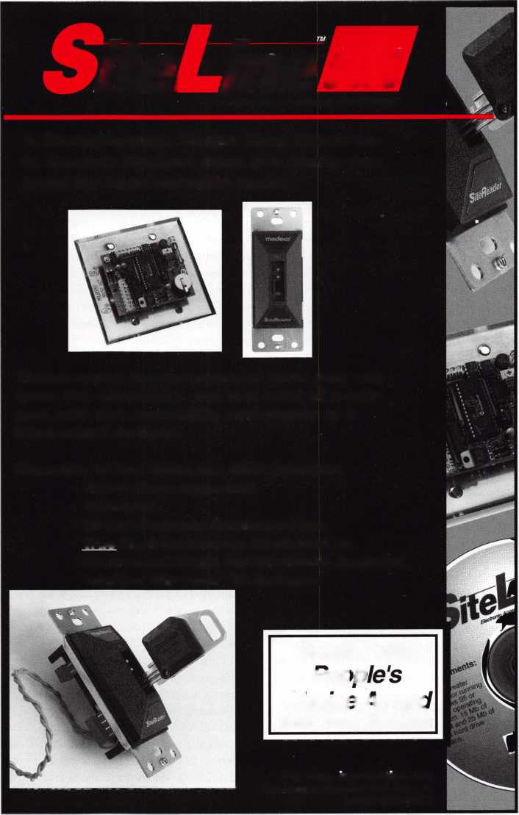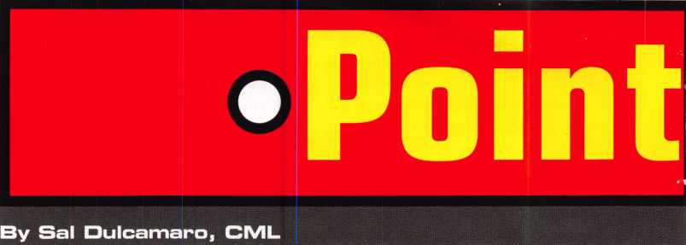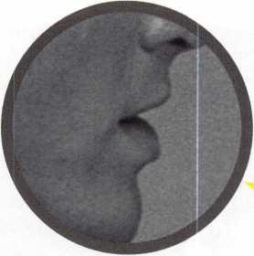

I’ve been a locksmith for over 23 years. Since I began in this field of endeavor, I can always recall some interest and discussion related to licensing of our profession. Years ago, for the most part, discussion was much more subdued. Among those who had an opinion, most were against or strongly against the idea. It had to be more than 10 years ago, but at one of the annual ALOA membership meetings, the subject of licensing or registration of locksmiths was under discussion. I recall that the majority voted to cut off any further exploration of the subject and its consequences. I was in the minority at the time.

I thought that we should have continued to explore the idea, but not actively pursue any legislation without more facts.

At the time, another topic of discussion was occupying many of us. This subject has raged before then and still continues. That topic has to do with the sale of lock picks or similar opening or bypass tools—devices that presumably should be exclusive (or near exclusive) domain of our profession. It seemed an apparent contradiction between the two issues, because making rules that would limit sales of such tools to locksmiths would be absolutely meaningless if there was no legal definition of a locksmith. Personally, I found myself more inclined in that direction now, as I observe certain patterns of evolution in our government.

In recent years, many leading voices in our industry have called for licensing of locksmiths. For the most part, these are the people who I highly respect. Many of their arguments seem reasoned and well thought out. Even if they are wrong, I don’t think for a second that they have anything but the best of intentions. Many of us

are aware, however, that the road to hell is paved with good intentions.

I have a personal history of not following the crowd or jumping on bandwagons, so I become a bit uncomfortable when everyone seems to be saying the same thing. It makes me cautious, and causes me to wonder exactly what is going on. That could just possibly mean that the majority voices are correct, but let us recall in history that as a people we believed the earth was flat and the sun revolved around the earth.

There are many bad varied arguments for licensing. It will prevent unqualified people from calling themselves locksmiths. It will protect the public from incompetents or criminals who might pass themselves off as locksmiths. It will raise the standards of profes­sionalism within the industry. Then there is the one argument that I believe has done the most to shift the majority opinion from anti-licensing to pro-licensing: to prevent related industries (electricians and alarm installers) from legis­lating us out of business with licensing and regulations instigated by them.

If licensing will accomplish all of that, sign me up. These sound like pretty good arguments for licensing. The question is: will it really accomplish all of that? In years past, the arguments were all theoretical. Looked at in laboratory conditions, if A is done, B will result. We live in a real world, and laboratory test results don’t always work the same in a real world. Things have changed, though, we have some real world examples to examine. In the last few years, a number of states have enacted some form of licensing of locksmiths. I don’t know what others think, but I’d sure like to know their experiences before and after licensing.

Has it benefited all locksmiths, just some or maybe none?

I think it is ultimately reckless to proceed with a policy of seeking legislation to require licensing, until we examine the fruits of in action already taken. Those who want to go ahead full steam could very well be right, the risk of action while other industries are moving forward could be greater than the risk of action and ending up with just a mediocre law.

I, however, would like to see the evidence to back such an argument. I would like to hear the

dissenting voices, especially those who are now living with the consequences of licensing.

I’ve heard the argument that we need licensing to cut out a niche for ourselves (especially in the area of electronics) so that electricians or alarm installers can’t place such work under their control. Presumably, that would require us to have either an electrician’s or alarm technician’s license to work on certain locks.

Who says that just because we shackle ourselves to government regulation and restric­tion—in exchange for allowing us to install and service electronic locks—that the law can’t be changed later to require us to get an alarm technician’s license anyway? Doesn’t history teach us otherwise? Early in this century, the folks who wanted to make alcohol illegal, succeeded with prohibition. I presume they thought that fight was won. In much more recent history, we can look at tax codes. People invested in certain ways because of presumed protection from taxation, only to have the law change and cost them great sums of money.

The other question I have is this: why do locksmith license laws seem to be structured so much differently than the ones pushed by the alarm industry? Maybe I have misread this aspect, but it seems that when the alarm industry gets their regulation in place, you can’t engage in those particular activities without holding an alarm license. It seems that the licensing for locksmiths only allows us to keep on doing what we already do for the price of an annual fee.

Anyone else, however, can engage in the same activities (without a license) as long as they don’t call themselves locksmiths. A state law that requires licensing of locksmiths does not prohibit anyone who is not a licensed locksmith from opening, servicing or installing locks. Can a licensed locksmith in Illinois or California walk into a hardware store and (after discovering that nobody there holds a locksmith’s license) get the law to force them to cease and desist in rekeying locks? An alarm technician in my state of Michigan (where alarm technicians are licensed) could report a locksmith installing alarms without a license and there would be legal repercussions.

Keynotes

September 1998

And I don’t buy public protection arguments. The only public that any industry fights is itself. Not when they’re spending their own money. Those arguments just give political cover to bought politicians. I wouldn’t be surprised if when the alarm industry gets laws passed to stop locksmiths from installing electronic locks, they argue that they are protecting the public from idiot locksmiths who will unwittingly electrocute the general public.

As I’ve grown older, I’ve found myself leaning towards the libertarian direction. Freedom surrendered to the government is rarely, if ever, returned to the people. Because of other forces and powers in play, it’s possible that licensing is the lesser of two evils. Before accepting that, however, I want to be sure that I’m not giving up the options of no evils.



As a locksmith, a member of ALOA and a member of the Illinois Private Detective, Private Alarm, Private Security and Locksmith Board, I have worked on locksmith licensing issues for over a year.

I have learned a lot on how the Private Detective, Private Security, Alarm, and Locksmith Law is enforced. The law itself has been in place for over 12 years, but locksmiths are a recent addition.

Our license came into being because we did our homework and had a book full of newspaper articles on “bad locksmiths” in Illinois. While the bill was in Springfield, two more “locksmith-burglars” hit the news. The fact is, our legislators and governor decided the public would best be served if the locksmiths they called out to

service their security problems met the same criteria as the other security profes­sionals in our state. These laws do protect the public and do not provide political cover for “bought politicians.” No contribu­tions were made to legislators prior to our law’s passage, and very few since.

I agree it would be nice to sit back and wait to see how licensing is working; I too am a cautious person. I am very aware that Illinois is in the spotlight and we are working very hard to keep our Illinois locksmiths educated about their new responsibilities. But if you’re looking for evidence to back licensing legislation, look to Illinois.

The law describes what is uniquely locksmith activity. The Locksmith Board members, Illinois Department of Profes­sional Regulation (IDPR] lawyers and staff work together to interpret the law and rules so that the intent of the law is enforced.

I understand the argument that anyone can engage in the same activities as long as they don’t call themselves a locksmith.

A common misunderstanding of our law is that you have to use the word “locksmith” to be in violation for holding yourself out to the public as a locksmith. Rekeying locks but calling yourself a handyman does not exempt you from the law. The I DPR considers a person holding themselves out as a locksmith when they perform an activity that is considered to be that of a locksmith. Examples of this include opening locks, recoding, programming, or rekeying locks, making keys by code or originating keys.

Recently, a towing company owner was told by I DPR he could not advertise “opening service” in his radio ad or in the Yellow Pages where he now advertises under “Locksmiths.” The owner agreed to change his radio ad and would get a locksmith license so he can continue to advertise this service. He will now have to pass our examination, ALOA’s PRP with sections on Life Safety Codes and Basic Electricity. If he is not competent to pass the exam, he will not be able to obtain a locksmith license.

You must realize however, that some of the work we perform as locksmiths is not unique to us alone. To allow carpenters to install door hardware, towing services to service stranded vehicles, and alarm companies to install locks and keypads with their security systems, our law has logical exemptions. However, these exemptions place limits on the service provided when that work becomes mainly locksmith work. At that point, they must have a locksmith license. For instance, ALOA has alerted the I DPR when local police enforcement open cars in “non­emergency” situations.

Enforcement will be toughened up as time passes. The I DPR will use Cease and Desist Orders, summon individuals and companies for hearing, issue fines and penalties determined by IDPR and Board members. Companies and individuals determined to be practicing without a license can expect to be fined and possibly face a Class A Misdemeanor charge on the first conviction and a Felony charge on a repeat offense.

Over the past year I have presided at hundreds of hearings. Until recently, they were all Private Detective, Alarm and Security Guard cases. I’ve seen fines levied from $100 to $30,000 and I've seen licenses revoked and suspended. Our law has teeth, the locksmiths violators just haven’t seen them yet.

I’m glad we didn’t wait in Illinois. Alarm companies are filing complaint after complaint of unlicensed practice against companies who are bidding against them on electronic access control jobs. Because we are licensed to do electronic access control by our license, locksmiths hold their rightful position in the field of electronic access control. Watch and wait if you like-but don’t blame anyone else, like your association, if you wait too long.

oooo

September 1998 Keynotes 111

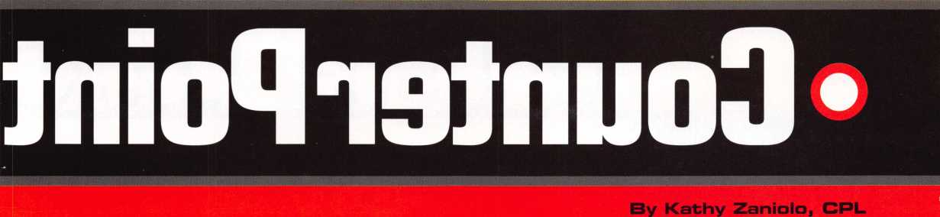

Servicing the common pin tumbler lock cylinder is usually a fairly straight­forward proposition. Regardless of the brand name, for the most part, one lock is not that much different from the next. Knowing the proper standard service procedures will usually prepare us for most new locks that we see for the first time. I’ve been in this business long enough to know that there are plenty of exceptions, where all the standard rules don’t apply. Still, when you calculate the percentages, the number of odd or unusual locks (compared to the vast number of standard locks) is very small.

When you confront the exceptional lock, knowing that it is not common doesn’t change the fact that it is the lock occupying your time at that moment. Until you complete the job, that peculiar lock is 100 percent of what you’re working on. Over the years I have seen quite a few unusual locks that required unusual servicing methods. In recent months, I’ve run into two different locks that fit that description.

The PADO Profile Cylinder

Photo one shows a profile cylinder with the brand identification “PADO.” It is used on heavy duty residential storm doors. I wasn’t able to find any readily available printed material on this particular lock, so I resorted to a bit of experimentation. It reminded me a bit of the Brazilian-made Papaiz profile cylinder, which is also used on heavy duty storm doors.

It is my impression that the PADO cylinder is also made in Brazil, but I’m not absolutely certain. The Papaiz profile cylinder looks more oval in shape compared to the PADO cylinder that looks like a rectangle with slightly rounded corners.

A side view of the PADO cylinder is shown in photo two. I’m not sure why, but the key orientation for most European and South American profile cylinders (as far as I can determine) is opposite of what we are used to in the United States. We are used to a cylinder oriented so that the cuts of the key face upward when inserted into the keyway of the lock. Like other import cylinders, the PADO cylinder requires the key to be inserted with the key cuts pointing downward. Because of that, make note that the cylinder in photo two is actually upside down.

This profile cylinder is keyed on both sides with two actuating cams in the center, at the back of each cylinder plug. The design of this profile cylinder (as with most types of profile cylinders) doesn’t allow the use of a standard plug follower in order to remove the plug for rekeying or other servicing. Looking at the bottom side of the cylinder in photo three, you can see six pin chamber openings on each end. Most locks of this style would use pin chamber caps to seal each pin chamber. This uses a long

pin that inserts and removes through the face of the lock cylinder to cover all the pin chambers from each end.

A more detailed view can be seen in photo four. The long pin has been partially withdrawn on the left side, exposing what is underneath in the last three pin chambers. This is a five pin tumbler lock cylinder. Tumbler springs can be seen in the fourth and fifth chambers. The sixth (last) chamber has a pin in it. There was no spring above this pin, and it is not a tumbler. It is a retainer pin that (when pushed back in the chamber) rides in a slot toward the back of the cylinder plug and keeps the plug from coming out of the lock cylinder shell. Removing the long pin that covers the pin chambers will allow you to remove the tumblers for either decoding the lock or rekeying it. The retainer pin does not have to be completely removed from its chamber in order to release the plug, but it must move upward enough to disengage the plug slot.

Moving the long pin that acts as a pin chamber cover is a slightly awkward operation.

I had to get a very small tipped (and fairly strong) tool toward the back of the sixth pin chamber, and get behind the back end of the long pin. The pin is normally flush with the front surface of the lock cylinder. By prying the pin forward toward the face of the cylinder, the pin began to protrude from the face of the cylinder. I had to move the pin far enough so that it no longer covered the sixth chamber and so the back end of the pin was in view through the fifth chamber. Next, I worked through the fifth chamber and advanced it until the end of the pin was in the fourth chamber. When the pin was sticking out far enough, I took a pair of pliers and grabbed the pin, pulling it

PHOTO 1

PHOTO 2

PHOTO 3

Keynotes September 1998

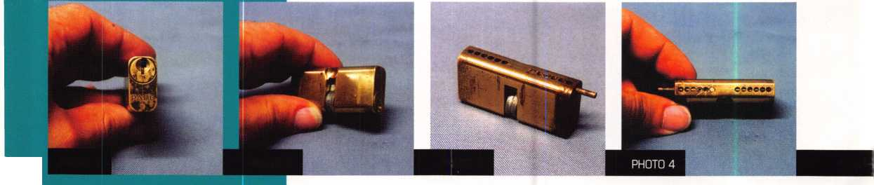

completely out. You must be careful not to excessively bend or break the pin, if you intend to reassemble the lock.

Prying through the pin chamber holes slightly deformed their circular shape and left some burrs. I had to adjust the metal at the top of the chambers a bit, in order to allow the tumblers to come out of the holes. Reassem­bling was much easier. After reloading the tumblers and springs, I reinserted the pin that covered the chambers and carefully tapped it into place until the pin was flush with the face of the lock cylinder. I didn’t have a proper PADO key blank, but I was able to use an Ilco 1000G key blank without much problem. The top of the key blade didn’t completely reach the top of the keyway, so I don’t know if it can create the shallowest depth to accommodate PADO’s shortest bottom pin. It worked okay with the shortest pin I found in this particular lock, which was about .172 inch. I don’t know official spacing dimensions, but I came up with approximate measurement of .155 inch from the shoulder to the first cut. The between cut spacing was somewhere between .138 and .140 inch. I don’t know; if PADO lock cylinders are imported separately from the doors in which they are installed.

**Yale Die-Cast Rim Cylinder**

This next unusual circumstance has to do with retainer clips. I don’t know how many years ago that I first saw the current version of the Yale rim cylinder. This version appears to be made in England. I presume the earlier version was made in the United States. Photo five shows a back view of the Yale rim cylinder and its less than ordinary retainer clip. I’m not sure how clearly you can make it out from the

photograph, but it is something between a “C” clip and an “O” clip. A regular “C” clip normally snaps on and off rather easily, since the “C” shape does not entirely encircle and entrap the end of the plug. This clip is not a snap ring, but the two ends of the clip almost touch. The metal is very flexible and the first time I saw one of these, some years ago, I spread the ends apart some distance until the clip came off and released the tail piece. When I later reassembled the lock, I had to bend everything back together, which at the time was a bit awkward. Spreading the ends so far apart and then squeezing them back together, I was concerned that I might break the clip.

Over the years, when servicing these cylinders, I’ve tried to figure a better way to do it. Recently when servicing a cylinder of this type, I revised my method. This Yale cylinder is die-cast with blind chamber holes. There is no tumbler retainer cover at the top side of the pin chambers. During manufacture, the chamber holes are drilled from the bottom of the lock cylinder shell upward just short of the top surface of the shell. Since holes are drilled through the bottom, an unmodified cylinder would allow the bottom pins to fall through when the plug was rotated 180 degrees. To prevent that, a flat metal cover blocks those holes at the bottom end of the lock. The narrow gap of the ends of the retainer clip is narrower than the width of the flat metal cover, which prevents the cover coming off during normal lock operation.

Photo six shows the first step of my modified service procedure. With the key inserted, I rotated the plug 180 degrees. Instead of bending the retainer clip far enough to remove it, I spread the gap just enough to be wider than

the flat metal cover that plugged the drilled holes on the bottom of the lock cylinder. Then I used a sharp poke tool to press into the metal plate (through one of the holes) and force it out slightly, as in photo seven. I was then able to grab the end of the metal piece sticking out, and pull it out as far as I needed to expose the pin chambers. I could then tip out the bottom pins, as in photo eight.

Once the five bottom pins are removed, you need to remove the old key and insert a new key with different cut depths. It might be a good idea to very slightly rotate the plug before removing the old key and replacing with the new one. That way the top pins in the upper pin chamber will not drop into the bottom of the keyway. When the new key is fully inserted, make sure the chamber holes in the plug line up with the drilled holes in the bottom of the lock cylinder. Place the correct bottom pins in the chambers and then slide the metal plate back in its slot to plug the holes. Squeeze the retainer plate back together and the job is done.

I’m not sure if this is Yale’s recommended procedure or if they suggest bending the retainer further to remove it and then remove the plug. Either method will work.

***Keynotes***

September 1998

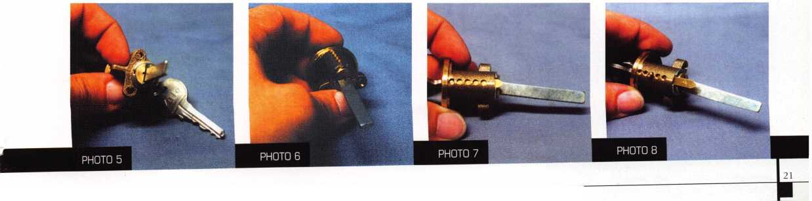

***Keynotes***

September 1998

How can you get involved with Crime Prevention month?

H you haven’t already started asking yourself this question after perusing this “Crime Prevention” issue of Keynotes then maybe you should.

After all, many neighborhood watch groups will benefit from the knowledge and expertise that you, as a security professional, possess. The big task is finding out when and where you can speak to interested citizens on the various security tips and tricks necessary to protect a home from a potential burglary

One way of finding out when and where your speaking/educational skills may be best appreciated is to contact your community’s homeowners association to see who runs their regular meetings or to inquire about any organized “crime watch” groups in the area. Another way to find out this information is by contacting your city’s Police Department as oftentimes select officers are key figures in organizing meetings and events centered around the subject of crime prevention.

At press time, Keynotes made attempts to line up member speakers to conduct oral presentations at a neighborhood meeting. That was the easy part. More difficult than we discovered was finding an actual meeting where we could volunteer our services. After playing a few rounds of phone tag with both policemen and various homeowners’ groups, we soon learned that there were no meetings (of any sort) scheduled within the next month.

Taking the bull by the horns, we decided to sponsor our own crime prevention meeting. Our speakers would be our own very qualified and experienced speaker, Keynotes technical editor, David Lowell, CML, CMS and Senior Corporal Ron Carpenter of the Dallas Police Department who is an



instrumental figure in many of the city’s neighborhood crime watch meetings.

Once we had our professional speakers lined up, the next step was finding an appro­priate, centralized location to hold the meeting. Our choice (and one that may be the most appealing to you) was a nearby local library. After reserving a meeting room in the library came the slightly arduous task of promoting it.

The method we selected was simple and fairly effective as we designed flyers with the “who, what, when and where” listed on them and placed them on the library’s bulletin board and the windows of different shops within the area.

The meeting was scheduled at 6:00 pm (a

suitable hour for people to get to the library

after work, classes, etc.) on a Monday (a day

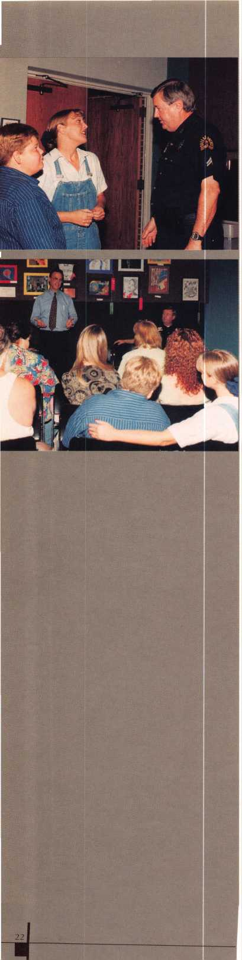

when most people don’t have anything planned). On meeting day, people began arriving just before the lecture started to socialize with each other as well as with David and Officer Carpenter.

David, well-prepared with literature to pass out, started the meeting off by thanking everyone for turning out and addressing the factors that cause citizens to become concerned with crime in their neighborhood.

He noted that being the victim(s) of an actual break in or knowing a victim often times promotes a sudden concern within people. Another factor was having a family that could be at risk during a break in. Likewise, the chance of losing personal items (documents, momentos, jewelry, etc.) also prompted citizens to further examine what stands between a burglar and their home.

As knowledgeable as David is, he did not trust his expertise enough to fly blindly through his presentation. With that, he had pre-prepared an orderly outline of what he would address.

For those interested in taking part in speaking to groups on the subject but have no experience in outlining a speech or oral presentation, a copy of David’s outline and the topics he covered are listed on page 24.

As you can tell, David had his bases pretty much covered. Afterwards, he noted that Keynotes visual aids could have benefited his overall performance. In describing door jambs, latches and other hardware, he felt that perhaps with photos or slides, various tips and instructions could have been better illus­trated.

Following his share of the presentation, David summarized the points of interest, reit­erating the tricks and pointers he discussed, before turned things over to Officer Carpenter. Carpenter, who has a total of 26 years experience on the police force (spending time as a street officer, then as a dispatcher and in the Dallas Police Department’s Personnel Department) said that one of his principal duties these days is organizing and working with existing crime watch groups.

Much of Carpenter’s speech reinforced David’s information, but he took things a tad further by enlightening everyone on the mentality that crooks take when choosing a home to break into. He says that many times, a crook may very well come right up and knock at a potential victim’s front door, just to see if anyone’s home. He may pose as a door-to-door salesman or a landscaper looking for work, but his real intent is to see if a home is occupied and maybe to take a peak inside when/if the door is opened.

He also said that once a burglar selects a home, the most common method of entry is by sheer force. With that, much of David’s section on “Doors” was restated and for very good reason.

In all, both David and Officer Carpenter worked well together as each one’s verbal

exhibition complemented the other’s. Likewise, it was a good way for ALOA and the Police Department to establish contacts with each other, as Carpenter said he may turn to us as a resource for future speaking engagements.

But the important lesson to be learned from this experience isn’t solely how to become involved in Crime Prevention Month, but rather how to use your skills as an asset for your community. After all, Crime Prevention Month should be EVERY month, so as security professionals, we should all do our part to educate the masses.

September 1998

Hi-



1. INTRODUCTION
2. MAIN TOPICS
3. Exterior
4. Doors
5. Windows
6. Alarms
7. Keys
8. SUMMARY

I. INTRODUCTION

“What are some of the considerations that should cause you to be concerned with home security?”

1. Being subjected to personal injury in the event that you or your loved ones are home at the time of the burglary.
2. Coming home to a house that has been vandalized by burglars.
3. Coming home to an empty house.
4. Monetary or Property loss (even if you are insured there is a deductible).
5. Loss of personal information or irreplaceable keepsakes.
6. Emotional stress (the feeling of your home being violated).

“The burglar looks for the weak home, the one with the open or unlocked door, a broken window, or one that allows easy undetected entry.”

II.MAIN TOPICS

1. Exterior

“Let’s view your house from all sides and ask some questions.”

1. Landscaping (overgrown or hanging over doorways or windows).
2. Lighting (is there good lighting in areas of access) (motion activated or timed).
3. Garage windows/doors (garage windows and doors secure—if not, someone can easily get into an attached garage and be able to spend a lot of time getting into the house undetected).
4. Doors
5. There are at least six ways to enter a door without authorization:
6. A door that is unlocked or not latching properly (someone could just walk in without your authorization).
7. Low grade residential locks that can be easily picked (just a few seconds).
8. Use of a copy of stolen key.
9. Drilling the lock cylinder with a cordless drill (approximate time 35-45 seconds).
10. Force such as kicking the door in.
11. Wedging or prying the door from the door frame.
12. Ways to secure doors.
13. Lock the doors!
14. Is the primary lock functioning?
15. Is there a deadbolt lock?
16. Does the deadbolt lock have a 1" throw?
17. Does the strike plate anchor through the doorframe into the structure of the dwelling?
18. Are all the locksets keyed alike throughout the dwelling?

(to prevent fumbling around for keys while in the doorway.)

1. Are the door frame and hinges secure? (Doorframe should be solid wood without gaps to prevent flexing from prying. If the door opens out, the hinge pins should be non­removable, or door pins should be installed that prevent the door from being opened from the hinge side.)
2. Windows
3. Do the windows have locks on them?
4. Are the windows securely mounted? (Many window locks can be slipped with a blade or shim—use clamps instead.)
5. Alarms
6. First of all, alarms only activate if there has been a break-in. (Don’t you think you need to take other security precautions even if you have an alarm?)
7. Is the alarm monitored?

3- Are there glass break detectors?

1. Is there a remote panic switch?
2. What is the response time in your neighborhood? (A burglar, even after the alarm has activated, can potentially make off with a few hundred or thousand dollars worth of your belongings in under 60 seconds.)
3. **Keys**
4. Have you re-keyed your locks recently?
5. Can you account for all of the keys?
6. Have you left your keys with a garage or valet? An ex-spouse, roommate or tenant?
7. Did you know that on most popular residential grade locks there are only about 5,000 usable variations of keys? That means in a large metropolitan area, there are probably 200-400 other houses whose tenants have keys that match your house.
8. Consult your local locksmith about patented key control locks and keys with millions of usable key combinations so that you can be sure that only you and those you authorize have keys to your dwelling.

III. SUMMARY

1. Check the exterior of your home for trimmed landscaping and good lighting.
2. Make sure that you have good quality deadbolts with reinforced strike plates that secure to the structure. Get in the habit of locking all doors.
3. Check all of your windows; install lock clamps on them to prevent lifting and prying.
4. Ask questions about your alarm system. Don’t depend solely on the alarm system for security.
5. Be conscious of key control. Take the time to consult with your local locksmith about ways that you can have absolute control over your keys.

“Keep tabs on who has keys to your home. Change locks if keys are

lost or stolen. If you’re about to move, change the locks before you

move in. This will prevent any previous tenant from having access.

If you’ve recently moved in, change all door locks as soon as possible.”

Keynotes

September 1998

Once upon a time, not  
so long ago, locks and lock  
hardware were intended to  
bring a smile of pleasure to  
a person’s face because of  
their beauty. In that gilded  
age everything from lock  
escutcheons to sash pulls  
to cabinet slide bolts were  
designed to be attractive  
personal statements, rather  
than merely nondescript  
utilitarian blobs. While  
there have been a number  
of recognizable periods of  
ornate door hardware  
through history, the  
Victorian era created an  
abundance of examples  
where utilitarian objects  
were turned into mini  
works of art, and moreover  
this was done in a mass  
produced way that crossed  
class lines and economic  
strata, so that ornamentation  
was not just for the gentry.

The era also resurrected  
many previous historical  
motifs, and its effect on  
door hardware was felt for  
nearly half a century.

Ornate door hardware was dealt a death blow by the hard reality of the First World War’s appetite for war production, and was finished off by the aesthetics of modernism and by the austerity of the Great Depression. Ornate knobs are one of the lock related collectibles that are a personal favorite of mine from this period, as are the associated

ornate cast iron window and drawer pulls, latches and catches. The shapes and designs are quite varied, abundant, and are quite appealing. Most of the knobs were fashioned in brass or bronze, though other materials are occasionally encountered, including cast iron, wood, glass, porcelain, ceramic and white metal alloys.

There is an interesting personal sensory

element that comes into  
play with knobs and  
levers in particular. Did  
you ever stop to wonder  
how many knobs and  
levers a person fondles in  
their lifetime? Often the  
ornate design on old  
knobs bears the wear  
patterns of countless  
encounters with people’s  
hands: is there a way to  
measure how much  
material is removed by  
each opening?

Most of the major lock  
hardware companies  
active in the period  
engaged in a competitive  
proliferation of ornate  
designs, including Yale  
and Towne, Russell and  
Erwin (later Russwin),  
Corbin, Sargent, and  
others. For example, the  
1901 Sargent catalog lists  
ornate design styles  
purporting to represent  
German Gothic, English  
Gothic, French Gothic,  
Italian Renaissance,

French Renaissance, German Renaissance,  
Louis XTV, Louis XV,

Louis XVI, Rococo, Empire, Flemish, Moorish, Colonial, Elizabethan, Greek, Romanesque, Italianesque, and a number of other early historical periods. With the somewhat mind boggling choices, it was fortunate that they were illustrated so you could just pick what you liked.

September 1998

Keynotes1 **_**

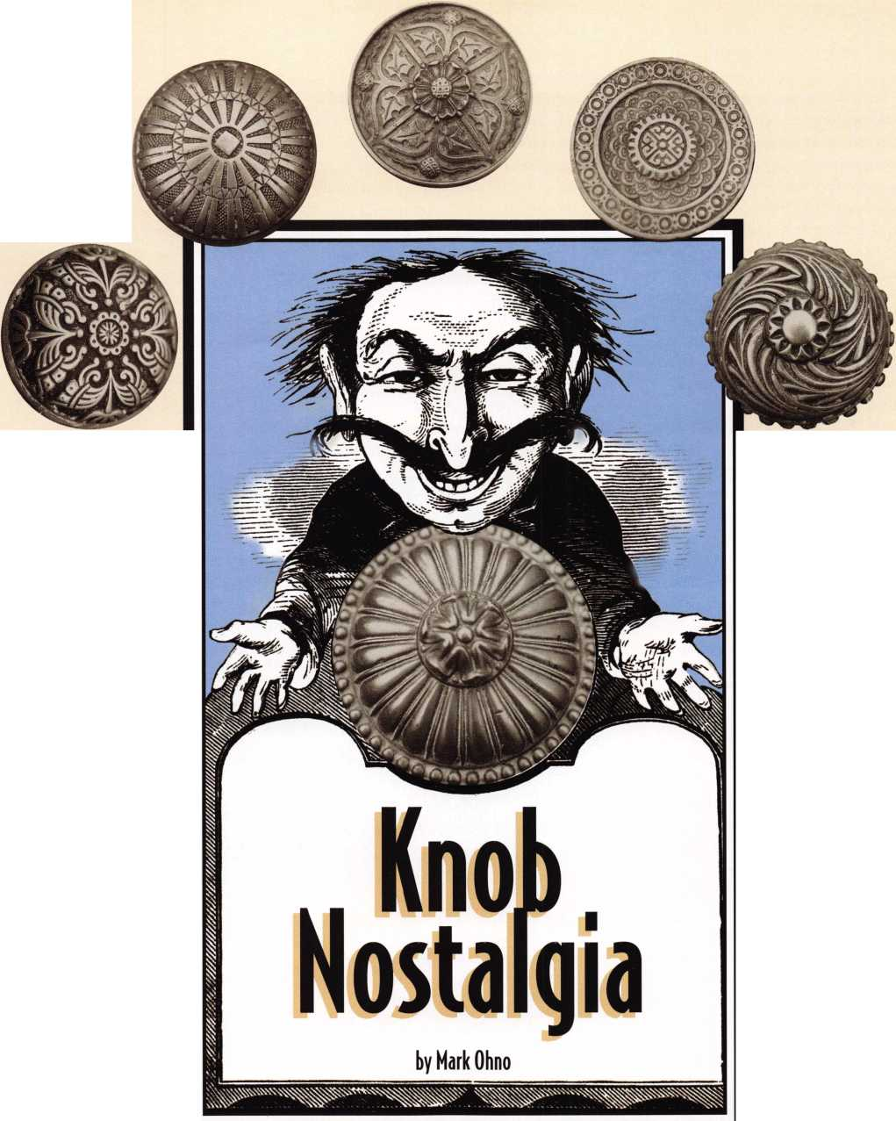

In addition to a rather generous offering of standard production motifs, it was quite common practice for manufacturers to produce semi-special designs for organiza­tions such as fraternal lodges. So one could obtain a somewhat generic Masonic or fraternal order knob, regardless of the particular chapter you were involved in. A church could obtain a knob with a cross on it, regardless of their particular denomina­tion. And then there were special knobs for specific banks, corporations, department stores, government entities, hotels and school systems, usually bearing their name or initials or logo.

Finally there were special designs unique to a single individual building of particular note, such as state capitols, or certain federal government buildings. Some of these special designs were quite common, and others quite rare. For example, the “New York School System” knobs, produced by Sargent and perhaps other companies, were manufac­tured in large enough quantity to make purloining one for use as an auto gear shift knob a right of passage for generations of teenaged motor heads. A number of what seem to have been “prototype” or trial knob designs that do not appear in catalogs also surface on musty sample blocks from the recesses of lock companies and their distributors, and the attics of former salesmen s houses from time to time.

Knob motifs of the standard designs by different companies are quite distinctive, and it is fairly easy to document and date them in the door hardware catalogs from the period. The Lock Museum of America in Terryville, Conn. (860)-589-6359 has a good reference library of catalogs, and these are available for on-site use by enthusiasts by arrangement, and the museum also displays a fine represen­tative collection of knobs. There is also an association of knob collectors. Many knobs from the late 1800s carry manufacturers logos (the style of which can be dated—see the lock museums historical research series #19), and some are marked with patent dates.

One advantage of knob collecting, over collecting something like antique safes, is that you can keep a lot of examples in a relatively small space, on display like some strange brass and bronze mushroom farm. Or even as a group of unusually heavy shoeboxes in the closet (army surplus 50 caliber machine gun ammo boxes work better as they are made for the weight, are compact

_A

previously been popularized. Of course this influenced everything from soap and perfume to clothing and hairstyles as it was integrated into all kinds of product marketing. Even into doorknobs and lock escutcheons. Designers, including hardware stylists, stole motifs from the graves of antiquity, so to speak, and those that didn’t actually go to the trouble of authenticity simply created designs that looked like they had.

The 1950s and ‘60s represented an entirely opposite world view: outer space and futurism were the exciting new horizons, not the past. You had Mies Van der Roh, the philosophy of “less is more,” and the resulting glass and steel edifices. Your car had rocket fins, and you bought the

**“...knobs are adaptive  
to a variety of uses:  
paperweights, tops for walking sticks  
or headknockers, gear shifts, coat hooks  
all in a row, and of course as  
a way to open non-ADA doors."**

and gasket sealed, are cheap, and have carry handles). This ease of storage is certainly a factor for those of us who are died-in-the- wool collectors and who realize that minimalist theory is claptrap: more is better and too much is hardly enough (or the one who dies with the most toys wins). And while prices are climbing, it is still possible to build a fine knob collection without having to mortgage your house. Very nice ornate brass and bronze knobs are still to be found smothered under layers of garish pink paint. And I even found some for the taking in a ghost town in New York state, of all places. And knobs are adaptive to a variety of uses: paperweights, tops for walking sticks or headknockers, gear shifts, coat hooks all in a

row, and of course as a way to open non-AD A doors.

To the average eye, ornate door hardware around the turn of the century might be seen to have been merely “fancy” or “decorative” or “ornate.” There was actually a bit more to it.

This was a period of great excitement over the discovery and opening of the Egyptian tombs, glorification of the Roman empire, and the birth of archaeology as an organized treasure hunt with records. So you had widespread glamorization of the ancient worlds in ways that fired the imagination of the popular press. Admiral Perry had opened Japan to the modern world, and missionaries and merchants visited other parts of the “mysterious” Far East, so you also had enormous interest in parts of the world that had previously been largely hidden from outsiders, and in particular, which had not

powdered drink of the astronauts at your supermarket. I have heard tales from employees of old lock companies of tons of ornate brass and bronze door hardware samples and left over parts being shoveled (literally) into factory cellars and covered over by bulldozers, broken up with sledge hammers, and thrown from second and third floor factory windows into waiting trucks for the trip to the scrap yard.

More recently, in the post modem architectural era, there is a more sympathetic attitude to history, and also toward Victorian embellish­ment, as well as enthusiasm for restoration of Victorian buildings and houses, though often as doctors’ offices or funeral parlors.

“Generic” ornate designs continue to be reproduced, and imported from places like Portugal and Italy. A company catering to the house restoration trade by the name of

***Keynotes***

September 1998

Greek design made by Sargent, circa 1901

Example of knob with Victorian motifs

Public school knob, a favorite acquisition as an auto shift knob

Renovator’s Supply has an enter­taining catalog. Of course colonial revival styles are a popular Baldwin stock-in trade. At a recent DHI show I was drawn to a table display by Accurate Lock showing ornate knobs and levers they have painstakingly replicated to match otherwise irre­placeable originals for facilities such as the Japanese Parliament building. Accurate will replicate any early design you wish (just bring your charge card with the highest limit, because this sort of custom work is not inexpensive).

When 2 3-year-old women lust  
after the gingerbread on a Victorian

over ones in with the rusty broken  
tools. But believe it or not, one of the  
very best sources can be the workers at  
scrap metal yards (my best source is),  
where they are turned in with the  
miscellaneous buckets of brass and  
bronze for scrap. Take some cards and  
an example or two of what you are  
seeking (especially ornate hardware  
with a zillion coats of thick white paint  
on it, which is how they are often  
found) and make friends with some of  
the yard workers. Another good  
potential source is the workers at  
demolition firms. They get to look  
around buildings before they come  
down, and lunch break can be

scrounging time. You might be surprised how many are already clued in to hooking up the backhoe to pull out copper wiring and burning off insulation in a barrel and other similar scrounging activities. For beer money you can have a whole network of guys bringing you goodies, and have a lot of fun discovering lost treasures.

Dalton Design by Sargent CA. 1901

carriage house, and everybody is fascinated by an ornate ship that sunk at the turn-of-the-century, then a revival of the popularity of ornate hardware may be just over the horizon.

It is still not tremendously hard to find original ornate hardware, especially in and around the older cities. They were used in both commercial and residential buildings. Firms that specialize in “architectural antiques” normally have examples among the gargoyles, plinths and cornices and columns from commercial demolition, albeit at a price. And usually polished and looking their best. Knobs and escutcheons also show up at antique flea markets and in antique shops, both as clean examples and as painted

Turn of the century lock catalog illustration

September 1998

Keynotes

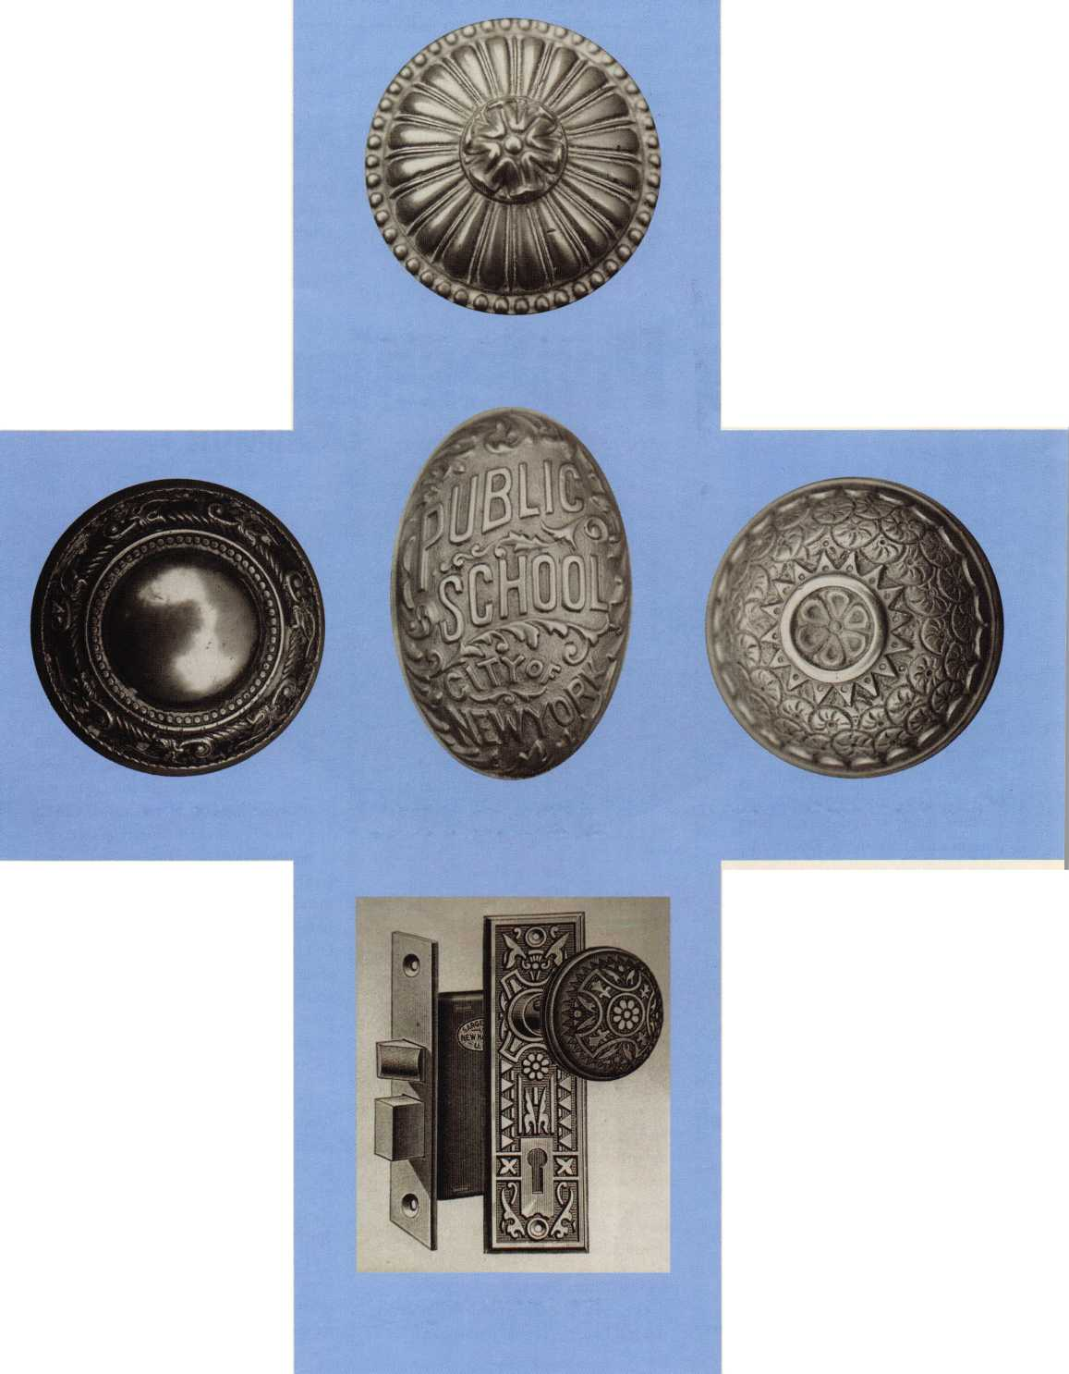

The professional locksmith has the unique  
opportunity to play a number of vital roles in  
the prevention of crime in today’s society. A  
role that many locksmiths find challenging as  
well as rewarding in both the financial and  
personal senses.

Being a professional locksmith, however,  
means much more than merely being a  
successful business person who duplicates keys  
or installs dead bolt locks. This demanding  
profession causes the locksmith to wear many  
hats during the course of a busy workday. The  
professional locksmith

is a knowledgeable  
consultant, a helpful  
salesperson and an  
expert technician.

**The Professional  
Locksmith as  
Consultant**

Every day you  
encounter a variety of  
customers in your

store, institution or on the job site  
for those of you who favor a mobile  
service. As you meet each of your  
customers, you have the  
challenge of providing them  
with the proper, up-to-the  
minute technical information  
necessary to answer their  
questions. This means that you  
need to keep abreast of the latest  
technical information by availing  
yourself of all the possible sources

such as ALOA and other educational

seminars, hands-on workshops, lectures,  
internet sites, trade shows, Keynotes and  
other magazines, newsletters, textbooks, etc.

The amount of information pouring in on a daily basis is nothing short of astounding! The difficulty lies in absorbing the information yourself, and then using your experience and expertise to disseminate it to your customers, so that they can make informed decisions. Consulting services are big business in today’s market, but it is something that you have been doing since the first day you opened your shop or began your locksmith career. The only difference is that in the “old days” we called it free advice.

Consulting services can be offered in such a manner as to encourage associate sales in the form of additional business for existing accounts or first time sales for new accounts. This has been a tried and true method for encouraging business for decades.

One of the best avenues for encouraging greater security is by providing a security survey

of the customer’s home or business. If the customer chooses to select one of your programs to upgrade security, then the survey itself should be completed for no additional charge.

Improvements, such as keyed window and patio door locks, dead bolt locks, high security lock cylinders, etc., which are second nature to you, have never been considered by the average consumer. However, in the event that the customer chooses not to select you to do the work that you have suggested, then they are liable for a fee that has been agreed upon

“This demanding profession causes the locksmith to wear many hats during the course of a busy workday.”

ahead of time. When this arrangement is structured in this way, it is a WIN-WIN situation for both you and your customer.

In either case, it is your responsibility to provide your customer with the necessary information on products and services to enable them to secure their home or business in a better and more professional manner than they would have been able to do without your consultation!

**The Professional Locksmith as Salesperson**

Once you have offered your expert advice, you still have the age old problem of

convincing the customer to buy those  
products and services from you. In other  
words, you have to close the deal!

I do not have to tell you how competitive  
today’s market can be. Competing on a day-  
to-day basis with the “box merchandisers” can  
be a nightmare, especially when they can often  
times sell popular products to your customers  
for less money than you can buy the same  
product yourself. You have to sell your  
customer on value. The best product to be  
applied in the proper manner to achieve the

desired result in a  
given situation.

For example, a  
customer buys a lock  
at one of the “big box  
stores.” The price is  
$9.99 for an entry.  
Your price is $ 15 for  
the same entry set.  
However, the “big box  
store” is either unable  
or unwilling to repin

the lock to your customer’s key.

When he comes to you to repin  
the cylinder, your price is  
$7.50. The total cost to the  
customer excluding the  
additional time to come to  
your store is $17.49! Had he  
come to your store in the first  
place, he would have been  
better off even if he had insisted

on the inexpensive lock. Make  
sure that you take this opportunity  
to educate your customer, so that next

time he can come directly to you and  
get the greater value by saving and money.  
The method that you use to close this deal  
involves a genuine sincerity on the part of the  
locksmith to help the customer receive the  
best balance of price and product. The  
cheapest security may not be the best for your  
customer’s needs. For example, one of the  
most neglected areas to be considered when  
purchasing a security product is the cost of  
insurance.

Let us look at two examples, that clearly  
illustrate this fact. First, let us analyze the cost  
of a high security lock cylinder as opposed to a  
standard lock cylinder. Let us say that the cost  
of standard lock cylinder is $10.00, and that  
the cost of a high security lock cylinder is  
$50.00. The business person that is looking  
for two mortise cylinders for the  
glass/aluminum door at the front of the store  
is having difficulty choosing the best cylinders  
for the job. Upon first seeing this discrepancy

Keynotes

September 1998

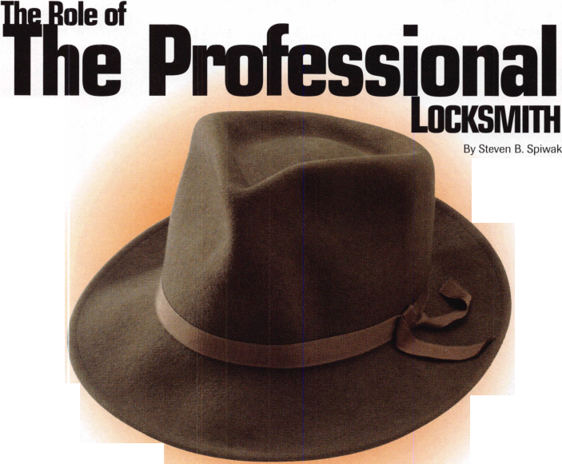

in price, the customer balks at purchasing the high security lock cylinder. However, once the differences are explained by a knowledgeable and helpful professional, the decision becomes clear.

The high security lock cylinder might net a small, but significant discount off his insurance policy due to the fact that this cylinder is pick resistant and provides key control. Over the course of time, the business person will benefit from the features found on the high security lock cylinders while reaping the benefits of the lower insurance rate, which could translate into signifi­cant savings. Overall, the high security lock cylinders in this example become the more advantageous choice for greater security and cost effectiveness.

The second example features automobile alarms. Let’s assume that the alarm is $500.00 installed. The customer wonders whether or not this additional security, which will lock the hood and activate a sophisticated alarm by utilizing a high security key, will in reality be advantageous.

Once again, the customer needs to look at the big picture. The price of the car on which this alarm is to be installed is priced at $25,000 dollars. The cost of auto insurance is

less when the car features an auto alarm. The average length of time for a loan on a new car is currently 60 months. Therefore, the customer will receive this additional security while saving approximately $100 per year off the insurance price for an unalarmed vehicle. At the end of the term of the loan , the car and the alarm will both be “paid off.” Now, if the customer decides to sell this car, he or she has two choices, both of which are good. First, he or she can sell the car for additional money because the alarm is installed upon the car in question, or second, he or she can remove the alarm before selling the car and have it rein­stalled on his new car for a small service charge! Once again, a WIN-WIN situation!

Being a knowledgeable and helpful salesperson who always has the best interests of the customer at heart will expand your business, create new opportunities and cement long-term relationships.

**The Professional Locksmith as Technician**

Now, you have surveyed the property in question, and you have sold the proper product or products to provide greater security against crime. What’s next? Now, you have to sell

yourself. You must convince the customer that a professional locksmith like yourself is the best qualified technician to complete this transaction by providing expert installation and service. The professional locksmith does this by making sure that the customer is aware of his or her creden­tials. Is the locksmith a CRL, CPL, or CML? If so, just what do these designations mean to the customer?

I know that when I go to the doctor for a check-up I am more comfortable if the diploma on the wall indicates that the doctor graduated from Harvard or Johns Hopkins than from some college or university with which I have no familiarity. If you have earned diplomas, awards, certificates, licenses, etc., display them proudly. Believe me, the customer is very interested in your qualifica­tions. Remember that you are the person that he or she is trusting to secure their home and family, business and livelihood. What could be more important than that? If every home and business would take our suggestions and let us make them a reality, the world would be a significantly more secure place to be!

"ComboGard... the professional's choice when **only** the best will do!"

Summer Special: ComboGard 33E-1

Metal Key Pad & Ring **(with small battery box)** d^$91.95

Sale ends 9/30/98

FEATURES

/Manager Code

Add/disable/remove second user code

/Dual Combination  
Allows for true dual-custody control

/Time-Delay

Delay period of 1-99 minutes with an open  
period of 1-19 minutes

/Time Delay Override

Ability to add a second combination to override

the delay period

/Silent Signal Alarm

Duress signal is sent if the last number of the combination

is entered one number higher or lower.

127 SE 29th Street ♦ Topeka KS 66605 ♦ 888 798 8464 / Fax 800 798 TIME (8463) ♦ 785 232 8705 / Fax 785 232 2603

Reader Service #5

September 1998

Keynotes

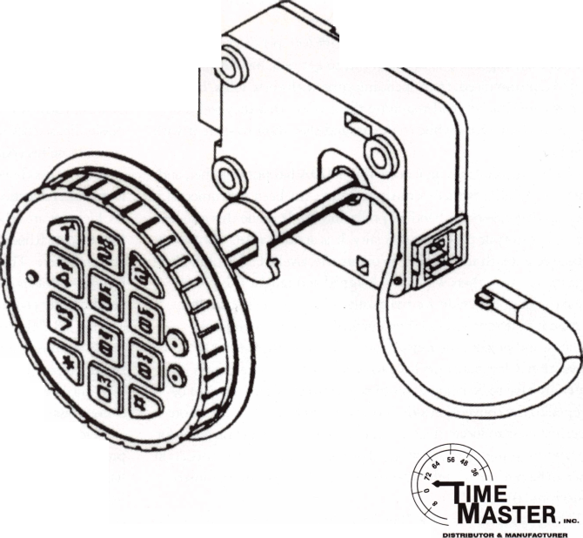

**K/ifH ALOA. CoHriHUiH**6 **EDUCAfioH**

By Paul F. Chandler, CRL

The ALOA convention in Nashville was the third which I have been privileged to share as an instructor. As such I have been in a position to observe first-hand the individuals who organize and implement this week-long educational conference. Those members who attend the convention and take classes see only the finished product. It is only human nature to take for granted the unseen efforts that go into making this event happen. I would like to share a few glimpses backstage at an ALOA convention.

The most visible members of the education team are the instruc­tors. After all, these are the faces you look at for eight full hours, standing up front in your classroom. Who are these people and why are they here?

Very few of the ALOA instructors are professional teachers or technical trainers. Some were technical instructors in the military. Others learned public speaking in previous careers. At least two developed their oratory style as ministers. For the most part, these are working locksmiths. Some are successfully self-employed. Some work for institutions. A few are employed by manufacturers or distributors of locks and hardware. ACE instructors are definitely not all cut from the same piece of cloth. Some of the instructors are quiet, like the gentlemanly Kenny Lee and the monkish Jerome Andrews. Others are more...how shall I put this...vivacious, like Ray D’Adamo. Amazingly, they all seem to get along great. At least they manage to bury the hatchet until the convention is over.

While ALOA does pay the instructors ($200 per day) and cover some of their expenses, no one is in this to get rich. So why do they do it? I am convinced, from spending time with these folks, listening to their conversations and watching them work, that they feel they have something worthwhile to impart and they want to share it with their peers.

The Instructor Training Course that ALOA has put together, and which all A.C.E. instructors must complete, has been instrumental in assuring that classes are handled professionally. It is one thing to be competent in your particular specialty. It is another thing altogether to be able to teach that subject to others effectively. Hal Tibbits, Ron Riggins and the others who have designed and taught this course deserve a lot of the credit for the quality of the classes you attend.

ACE instructors develop their curriculum, write their class outlines, and prepare their visual aids in the months before the convention. Class handouts have to be written. Demonstration materials have to be begged, borrowed or stolen. Crates have to be shipped to the convention site. Most instructors arrive a day before their first class to locate their supplies and set up their classrooms for the next morning. The day of the class we all gather in the education office to have a cup of coffee and to receive a few last minute instruc­tions from “the boss.”

For my first two years the “boss” was Jim Glazier, chairman of the Education committee. Jim and his fellow committee members worked their tails off to handle all the logistics of staging this

weeklong college of locksmithing. Crates of supplies have to be carted in and out of classrooms, thousands of photocopies have to be made, rosters are constantly being updated and certificates are prepared. This classroom is “too cold,” that one is “too hot,” the “lights won’t dim” in the next one and “where’s that overhead projector I ordered?”. In the midst of this bedlam Jessica Vasquez and a few other ALOA staff members quietly got the job done. Then there are the volunteers.

Volunteers like Bill Smith and his daughter Bobbi. Every year Bill and Bobbi are there, doing whatever needs doing. You’ve probably seen Bill, he’s the little guy with the giant heart and even bigger smile who doesn’t want any official position or any recognition. He’s just there to help. Guys like Bill are the grease that allow organiza­tions like ours to function.

This year, for the first time, we have had a new “boss.” David Lowell, recent past president of ALOA, has assumed the staff position of Education & PRP manager. I must say, Jim and the other committee members really seemed to be enjoying this convention more than ever. Under this new arrangement the board members can concentrate on planning and improving the quality of ALOA education and the staff can make it all happen. So if David looked like he’d been “rode hard and put up wet” it was only because he did about four weeks work in the nine or 10 days of the convention. David, and his able assistant Ashley Spencer, did a great job of organizing and planning the convention in advance, but Murphy’s Law always comes into play. This time it involved bird-brained convention center staff who decided we didn’t really need all those boxes of class materials that various instructors had air freighted to Nashville, so they sent them back. If this ever caused David to panic, or even lose his cool, I never noticed.

A lot of good people do a lot of hard work to make quality locksmith education possible. And there are plans to do even more. ACE classes are scheduled for upcoming months in New York City; Providence, Rhode Island; Jackson, Mississippi; Independence, Ohio and elsewhere. These are opportunities to take the same great classes we had in Nashville right in your backyard. In the future there will also be closer coordination between the instructors, their curriculum and the PRP electives that relate to those topics. This should result in test questions that are up-to-date and relevant as well as classes that better prepare you for the test. Exciting new classes are being introduced too, such as the three-day NBFAA alarm installers certifi­cation class, which was so popular in Nashville.

Before I had a chance to participate in the ALOA education program I never gave much thought to what it takes to make it happen or who the people are who get it done. The past three years have been an eye opener for me. Of course, nobody, and no educa­tional program, is perfect. But these folks are trying their best and they’re ready to listen to your good suggestions. You’ve got a quality resource here, I hope you appreciate it and use it.

Keynotes

September 1998

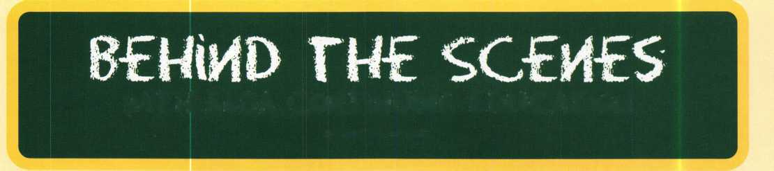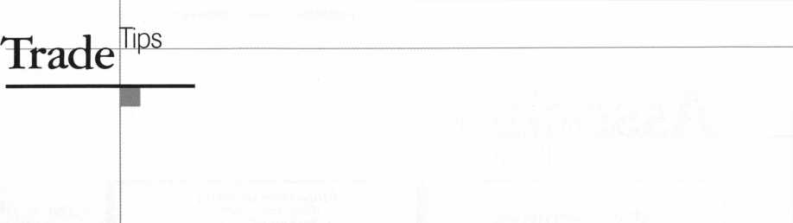

How To Become A

Trade Tipper

Each month, the Associated Lock­smiths of America (ALOA) holds a “Trade Tips” contest in Keynotes for ALOA members. In addition to helping other locksmiths by sharing your knowledge, there are three levels of prizes to be awarded:

Authors of any Trade Tip  
published will receive $20.

Monthly Prize for the  
best Trade Tip is $100.

The Grand Prize for the best Trade Tip of the Year is an expense-paid trip to the ALOA ’99 Security Expo

Each year, the ALOA Publications Committee selects one outstanding tip, the author of which receives a seven-day ALOA convention package that includes travel within the conti­nental United States and accommo­dations.

Want to Participate?

Mail your best idea [including photos,

illustrations or parts, if necessary) to:

Keynotes

Trade Tips Editor

3003 Live Oak St.

Dallas, TX, 75204-6186.

All entries are sent to the Trade Tips editor with the author’s identity delet­ed. The tips must be submitted exclu­sively to Keynotes and become the exclusive property of ALOA. Tips are judged on the basis of accuracy, pro­fessionalism, ethical standards, origi­nality and usefulness.

P!ugginf Away

To make a plug removal key for Hayworth office equipment cylinders, modify a Jet HK1/HK2 key blank by doing the following:

3/32"

(.094")

i i i i

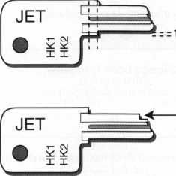

* Cut the top and bottom shoulders back 3/32” (.094”).
* Place the modified key blank in a code machine and cut a number four depth in the sixth position (HPC Card # CX32).
* File a corresponding notch on the bot­tom of the key blade 1/32” (.031”) deep and 3/32” (.094”) back from

the tip.

The plug must be turned to the unlocked position to be removed. To help retain the key in the plug while pulling the plug out you should cut a number five depth in the third space.

Victor Vigil #024734

The Wild One

Use boiling water to soften the black plastic covers on motorcycle ignition locks before prying them off. Warning: Some of the newer locks use a brittle plastic, so you will break the cover without softening it first. If you accidentally drop the whole lock into the water remember to use WD40 and contact cleaner on the electric contacts before handing it back. A black permanent marker will cover scratches on the lock.

Basil Shannon, CPL #004422

Got That Pegged

When I started up in business, I wanted to use pegboard and hooks for all the key- blanks. Luckily I met a man who was able to tell me how to do it properly. It seems that if you nail up a sheet of pegboard and stick hooks in it, it just sags and wobbles in the wrong places. The trick is to thoroughly wet the pegboard first, then nail it up to the bat­tens. As it dries, it contracts, leaving one nice tight straight keyboard!

Basil Shannon, CPL #004422

Last month’s Trade Tip winner was Glen S. Phillips for “Adams Right.”

About the Trade Tips editor:

I David Lowell, CML, CMS, is the

PRP/education manager for ALOA. He also  
serves as technical editor for Keynotes. Active for  
many years in ALOA leadership, David owns  
Phoenix Lock & Key in Arizona.

|  |  |  |
| --- | --- | --- |
| Keynotes Advertisers Index | | |
| its# | Advertiser | Page |
| 7 | Abus | 37 |
| 3 | BWD | 15 |
| 43 | DHI | 43 |
| 100 | Jet Hardware Mfg., Inc. | _ BC |
| 2 | Locksmith Publishing Corp. | 11 |
| 6 | MINK | 35 |
| 4 | Medeco | 17 |
| 1 | Security Technology & Design IFC | |
| 5 | Timemaster | 29 |
| 40 | TriRegional | 41 |
| 42 | Yankee | 42 |
|  |  |  |
|  | September 1998 | Keynotes |



**Associate**

|  |  |
| --- | --- |
| Members | 1 vy |
| Manufacturers | Arrow Lock Company  10300 Foster Avenue  Brooklyn, NY 11236 (718) 257-4700; FAX (718) 649-9097  sees |
| A & B Safe Corp.  171 S. Delsea Dr.  Glassboro, NJ 08028 (800) 253-1267; FAX (609) 863-1208  • • • • | Auto Security Products (A. S. P.)  P.0. Box 10  Redmond, WA 98073-0010 (425) 556-1900; FAX (425) 558-1205 |
| ASSA Inc.  10300 Foster Ave.  Brooklyn, NY 11236 (800) 235-7482; FAX (718) 257-2772  m | BWD Automotive  900 Ravenwood Dr.  Selma, AL 36701  (334) 874-9001; FAX (334) 874-6011  • • |
| Abus Lock Company  3555 Holly Lane North  Plymouth, MN 55447-0507 (800) 352-2287; FAX (612) 509-9939  e | Chicago Lock Company  10100 88th Ave.  Pleasant Prairie, Wl 53158-0069 (800) 445-3204; FAX (414) 947-7178  m |
| Adams Rite Manufacturing Co.  P.0. Box 1301  LaPuente, CA 91749-1301 (562)699-0511; FAX (562) 699-5094  • • | Corbin Russwin Architectural Hardware  P.O. Box 25288  Charlotte, NC 28229 (800) 543-3658; FAX (800) 447-6714  sees |
| Adesco Safe Manufacturing Co.  16720 S. Garfield Ave.  Paramount, CA 90723 (800) 821-6803; FAX (310) 408-6427  • | Curtis Industries  6140 Parkland Blvd, Ste. 300  Mayfield Heights, OH 44124-4103 (800) 555-5397  • • |
| Adrian Steel Company  906 James St.  Adrian, Ml 49221  (800) 677-2726; FAX (517) 265-5834  • | DETEX  302 Detex Dr.  New Braunfels, TX 78130 (800) 729-3839; FAX (830) 620-6711  III# |
| Alarm Lock Systems, Inc.  345 Bayview Ave.  Amityville, NY 11701 (800) ALA-LOCK; (516) 789-3383  m | Don-Jo Manufacturing, Inc.  P.O. Box 929  Sterling, MA 01564 (508)422-3377; FAX (508) 422-3467  <3> • |
| Aiphone Intercom Systems  1700-130th Avenue, NE  Bellevue, WA 98005 (206) 455-0510; FAX (206) 455-0071  ^ (0 | Door Controls International  2362 Bishop Circle East  Dexter, Ml 48130  (800)742-3634; FAX (800) 742-0410  see# |
| American Lock Co.  3400 West Exchange Road  Crete, IL 60417-2099 (708) 534-2000; FAX (708) 534-0531  t • | ESP Lock Products, Inc.  375 Flarvard Street  Leominster, MA 01453 (508)537-6121; FAX (508) 537-1699  • |
| American Security Products (AMSEC)  11925 Pacific Ave.  Fontana, CA 92337-6963 (800) 423-1881; FAX (909)685-9685  • • | Folger Adam Security, Inc.  16300 W. 103rd Street  Lemont, IL 60439  (630) 739-3900; FAX (630) 739-6138  e • |
|  |  |

Associate members of the Associated Locksmiths of America (ALOA) manu­facture or distribute materials or equip­ment, or provide services, for the securi­ty industry. Many have donated money, services and equipment to ALOA in addition to their annual dues. Their sup­port of ALOA projects enhances overall membership benefits and we encourage our members to patronize these firms. If you know of a potential candidate for associate membership, please contact the ALOA Sales staff at (214) 827-1701. Associate member dues are $500 per year and entide the payor to use the ALOA logo, and selected discounts on ALOA products and services.

Legend

9 Alarms: Personal, vehicle, electronic, fire, burglar, and exit

**9** Automotive: Lockout equipment, key chains/rings

**9** Builders Hardware: Door closers, furniture/decorative hardware, viewers, emergency exit devices

Books, reference guides, publications, computer software

**9** CCTV/Photo Imaging: Cameras, monitors, photo ID equipment, cables

**9** Electric/ilectronSc Security: Card access control and readers, surveil­lance, electric/magnetic locks and strikes, keypads

**9** Lock Devices: Auto locks, cylinders, emergency exit/entrance control, locks (various types), strikes

**9** Tools & Supplies: Key blanks, cutters, picks, rings/hooks, custom van/truck supplies



**32| *Keynotes***

September 1998

|  |  |  |
| --- | --- | --- |
| Fort Lock Corp.  3000 N. River Rd.  River Grove, IL 60171 (708] 456-1100; FAX C7083 456-9476 | Lucky Line Products  7890 Dunbrook Rd.  San Diego, CA 92126 (6193 549-6699; FAX (6193 549-0949 | Sargent & Greenleaf, Inc.  P.O. Box 930  Nicholasville, KY 40340-0930 (6063 885-9411; FAX (6063 887-2057 |
| •••••• | • | 9 © • 9 |
| Grobet File Co. of America  750 Washington Ave.  Carlstadt, NJ 07072 (8003 962-7242; FAX (8003 243-2432 | M.A.G. Engineering & Mfg. Inc.  15261 Transistor Lane  Huntington Beach, CA 92649 (7143 891-5100; FAX (7143 892-6845 | Schlage Lock Co.  1915 Jamboree Suite 165  Colorado Springs, CO 80920 (8003 847-1864; FAX (8003 452-0663 |
| • | • • • | • • |
| H.E.S., Inc.  2040 W. Quail Ave.  Phoenix, AZ 85027 (6023 582-4626; FAX (6023 582-4641 | MARKS USA  5300 New Horizons Blvd.  Amityville, NY 11701 (5163 225-5400; FAX (5163 225-6136 | Schwab Corporation  3000 Main St  Lafayette, IN 47903-5088 (7653 447-9470; FAX (7653 447-8278 |
| • • • | • | • |
| llco Unican  400 Jeffreys Road  Rocky Mount, NC 27804 (9193 446-3321; FAX (9193 446-4702 | MUL-T-LOCK USA, Inc.  300-1 Route 17 South Suite A  Lodi, NJ 07644  (8003 562-3511; FAX (9733 778-4007 | Securitron Magnalock Corp.  550 Vista Blvd.  Sparks, NV 89434  (8003 624-5625; FAX (7023 355-5636 |
| ••••••• | • • • | 9 9 |
| In Out Systems, Inc.  3650-A Matte Boulevard  Brassard, Quebec J4Y-2Z2, Canada  FAX (5143 444-2029 | Master Lock Company  2600 North 32nd Street  Milwaukee, Wl 53211 (4143 444-2800; FAX (4143 449-3114 | Security Door Controls  3580 Willow Lane  Westlake Village, CA 91361 (8053 494-0622; FAX (8003 959-4732 |
| <0 • | 9 9 | • |
| Jet Hardware Mfg. Co.  800 Hinsdale Street  Brooklyn, NY 11207 (7183 257-9600; FAX (7183 257-0973 | Medeco Security Locks  P.O. Box 3075  Salem, VA 24153  (5403 380-5000; FAX (5403 380-5010 | Security Solutions  1640 W. Hwy. 152  Mustang, OK 73064 (4053 376-1600; FAX (4053 376-6870 |
| • | 9 9 9 | 9 9 9 |
| KABA High Security Locks  P.O. Box 490  Southington, CT 06489 (8603 621-3601; FAX (8603 621-9727 | Meilink Safe Company  111 Security Parkway  New Albany, IN 47150 (8003 634-5465; FAX (8003 896-6606 | Sentry Group  900 Linden Ave.  Rochester, NY 14625-2784 (7163 381-4900; FAX (7163 381-8559 |
| 9 | 9 |  |
| KEY-BAK; Div. of W. Coast Chain Mfg. Co.  1460 S. Balboa Ave.  Ontario, CA 91762 (9093 923-7800; FAX (9093 923-0024 | NKL Industries Ltd.  1111-13 Cavalier Blvd.  Chesapeake, VA 23323 (8003 528-9900; FAX (7573 485-0271 | Sully Tools Inc.  3515 Nodding Pine Ct.  Fairfax, VA 22033  (7033 689-3416; FAX (7033 787-0869 |
| • • • • | 9 9 9 9 | ^ <|^ |
| Knaack Manufacturing Co.  420 E. Terra Cotta Ave.  Crystal Lake, IL 60014 (8003 456-7865; FAX (8153 459-9097 | National Cabinet Lock  200 Old Mill Road, P. 0. Box 200  Mauldin, SC 29662 (8643 297-6655; FAX (8643 297-9987 | TIB Canada Ltd.  2164 Oneida Crescent  Mississauga, Ontario, Canada L5C IV6 (9053 566-9198; FAX (9053 566-9697 |
| • | • | • 9 9 9 9 |
| LAB Security  700 Emmett St  Bristol, CT 06010  (8003 243-8242; FAX (2033 583-7838 | Newman Tonks  805 N Buckman St.  Shepardsville, KY 40165 (8003 826-5792; FAX (8003 777-8229 | Taymor Industries, Inc.  1586 Zephyr Ave.  Hayward, CA 94544 (8003 388-9887; FAX (8003 288-8133 |
| • | • 9 | • # |
| LCN Closers (Division of Ingersol)  121 W. Railroad Ave.  Princeton, IL 61356 (8153 875-3311; FAX (8153 875-3222 | ROFU International Corp.  2004-B 48th Ave.; Court E  Tacoma, WA 98424 (8003 255-7638; FAX (2533 922-1728 | Trine Products Corporation  1430 Ferris Place  Bronx, NY 10461  (7183 829-4796; FAX (7183 792-9127 |
| • | • | 9 9 9 |
| La Gard, Inc.  3330 Kashiwa Street  Torrance, CA 90505 (3103 325-5670; FAX (3103 325-5615 | Rutherford Controls Inc.  2697 International Pkwy, Bid 5 #100  Virginia Beach, VA 23452 (7573 427-1230; FAX (8043 427-9549 | Weiser Lock Company  6700 Weiser Lock Blvd.  Tucson, AZ 85746  (5023 741-6338; FAX (5203 741-6363 |
| • • • | • | • 9 |
| Lori Lock  P.O. Box 1040  Southington, CT 06489 (8603 621-3605; FAX (2033 621-5972 | STRATTEC Security Corp.  3333 W. Good Hope Rd.  Milwaukee, Wl 53209 (4143 247-3333; FAX (4143 247-3329 | Yale Security Inc.  P.O. Box 25288  Charlotte, NC 28229-8010 (8003 438-1951; FAX (8003 338-0965 |
| • • | • • • | • 9 9 9 |
|  |  |  |

September 1998

Keynotes

|  |  |  |
| --- | --- | --- |
| Zhongshan Hua Feng Lock Products  S Yongning Industrial Road, Ziaolan Zhongshan Guangdong, China  86-760 227 82 63; FAX 86-270 227 80 63  • | Direct Security Supply, Inc.  36 Lincoln Street  Boston, MA 02135 (800) 252-5757; FAX (800) 452-8600  ^ (|J) @ ^ (p (Q | IDN, Inc.  1000 S. Main, Suite 280  Grapevine, TX 76051 (817)421-5470; FAX (817) 421-5468 |
| Distributors | Doyle Lock Supply  2211 W. River Road N.  Minneapolis, MN 55411 (800) 333-6953; FAX (612) 521-0166 | Intermountain Lock & Supply Co  3106 South Main Street  Salt Lake City, Utah 84115 (800) 453-5386; FAX (801) 485-7205 |
| Accredited Lock Supply Co.  P.O. Box 1442  Secaucus, NJ 07096-1442 (800) 652-2835; FAX (201) 865-5031  @ ^ | Dugmore & Duncan Inc.  30 Pond Park Rd.  Hingham, MA 02043 (800) 225-1595; FAX (617) 740-4043  ^ | JLM Wholesale, Inc.  3095 Mullins Ct  Oxford, Ml 48371-1643 (800) 522-2940; FAX (800) 782-1160  • • • |
| Ace Lock & Security Supply Co.  565 Rahway Ave.  Union, NJ 07083-6631 (800) ACE-LOCK; (800) ACE-FAX4 | E. L. Reinhardt Co., Inc.  3250 Fanum Road  Vadnais Heights, MN 55110 (800) 328-1311; FAX (612) 481-0166  •••••• | Jo-Van Distributors Inc.  929 Warden Ave.  Scarborough, Ontario MIL 4C6 (416) 752-7249; FAX (416) 752-3845  ••••••••••• |
| Akron Hardware Consultants, Inc.  2579 South Arlington Road  Akron, OH 44319  (800) 321-9602; FAX (800) 328-6070  <9> ® | Ewert Wholesale Hardware  4709 W 120th St  Alsip II 60658  (800) 451-0200; FAX (708) 597-0881  • • • • • | Lockmasters, Inc.  5085 Danville Road  Nicholasville KY, 40356 (606) 885-6041; FAX (606) 885-7093  • • • • |
| American Security Distribution  4411 E. La Palma  Anaheim, CA 92807 (714)996-0791; FAX (714) 579-3508  ••••••• | Fairway Supply, Inc.  2631 Lombardy Lane  Dallas, TX 75220  (214)350-0021; FAX (214) 352-4299  ^ ^ ^ | Locks Company  2050 N.E. 151 St.  N. Miami, FL 33162 (800)288-0801; FAX (305) 949-3619  @ (0 (j^ (fi ^ |
| Andrews Wholesale Lock Supply  544 S. 9th St.  Lebanon, PA 17042-6608 (717) 272-7422; FAX (717) 274-8679  • | Foley-Belsaw Company  6301 Equitable Road  Kansas City, MO 64120 (800)821-3452; FAX (816) 483-5010  • • • • | The Locksmith Store Inc.  1229 E Algonquin Rd. Suite E  Arlington Heights, IL 60005 (847) 364-5111; FAX (847) 364-5125  • • • • |
| Boyle & Chase Inc.  P. 0. Box 74  Accord, MA 02018-0074 (800) 325-2530; FAX (781) 335-5342  • • • | Fried Brothers, Inc.  467 N. 7th St.  Philadelphia, PA 19123 (800) 523-2924; FAX (800) 541-3489 | M. Zion Company  69 Reade Street, 4th Floor  New York, NY 10007 (212) 349-8677; FAX (212) 964-0495  ••••••• |
| Clark Security Products, Inc.  4775 Viewridge Ave.  San Diego, CA 92123-1641 (800) 854-2088; FAX (619) 974-5284  •••••••••• | HS&S Wholesale Distributors  12915 West 8 Mile Road  Detroit, Ml 48235  (800) 521-2202; FAX (313) 342-7580  @ ^ ^ | McDonald-DASH Locksmith Supply  5767 E. Shelby Dr.  Memphis, TN 38141 (800) 238-7541; FAX (901) 366-0005 |
| Cook’s Building Specialties  2441 Menaul Blvd. NE; P.O. Box 37320 Albuquerque, NM 87176-7320 (505)883-5701; FAX (505) 883-5704  •••••• | Hans Johnsen Company  8901 Chancellor Row  Dallas, TX 75247  (214) 879-1550; FAX (214) 879-1530 | McManus Locksmith Supply, Inc.  P.O. Box 9231,1309 Central Ave.  Charlotte, NC 28299 (702) 333-9112; FAX (704) 332-8664  • • • |
| DiMark International  3117 Liberator St., Unit A  Santa Maria, CA 93455 (800) 235-2435; FAX (805) 928-8034  • t | Hardware Agencies, Ltd.  1220 Dundas Street East  Toronto, ON M4M 1S3 (416) 462-1921; FAX (414) 462-1922 | McMaster-Carr Supply Company  600 County Line Rd,  Elmhurst, IL 60126-2081 (630) 833-0300; FAX (630) 834-9427  ^ (§}> ^ |
| Dire’s Lock & Key Co.  2201 Broadway  Denver, CO 80205  (303) 294-0176; FAX (303) 294-0198 | Hardware Suppliers of America  P.O. Box 2208  Winterville, NC 28590 (800) 334-5625; FAX (800) 334-5635  ® ® | Monaco Lock Co.  339-345 Newark Ave.  Jersey City, NJ 07302 (800) 526-6094; FAX (800) 845-LOCK  ^ (p (Q |
|  |  |  |
| ®Business/1ech&Ed. fll Timhijt.n.  ■■ ■ ® Be^c/ElectnmicSecurity ah m  -5-;-. '■ ® Lock Devices | | |

***Keynotes***

September 1998

■

number for

Nation on

each item.

Reader Service

‘September 1998

Use this card to obtain more information about the products and services advertised or described in this issue.

**Card valid until Dec. 1,1998.**

Name _

Company

Street Address _ City

Phone_

_Title

_State .

_Country

FAX

_ZIP_

|  |  |  |  |  |  |  |  |  |  |  |  |  |  |  |  |  |  |  |  |
| --- | --- | --- | --- | --- | --- | --- | --- | --- | --- | --- | --- | --- | --- | --- | --- | --- | --- | --- | --- |
| 1 | 6 | 11 | 16 | 21 | 26 | 31 | 36 | 41 | 46 | 51 | 56 | 61 | 66 | 71 | 76 | 81 | 86 | 91 | 96 |
| 2 | 7 | 12 | 17 | 22 | 27 | 32 | 37 | 42 | 47 | 52 | 57 | 62 | 67 | 72 | 77 | 82 | 87 | 92 | 97 |
| 3 | 8 | 13 | 18 | 23 | 28 | 33 | 38 | 43 | 48 | 53 | 58 | 63 | 68 | 73 | 78 | 83 | 88 | 93 | 98 |
| 4 | 9 | 14 | 19 | 24 | 29 | 34 | 39 | 44 | 49 | 54 | 59 | 64 | 69 | 74 | 79 | 84 | 89 | 94 | 99 |
| 5 | 10 | 15 | 20 | 25 | 30 | 35 | 40 | 45 | 50 | 55 | 60 | 65 | 70 | 75 | 80 | 85 | 90 | 95 | 100 |

I

B

■

| nberfor r information on Ich item.

Card valid until Dec. 1,1998.

Reader Service

•September 1998

Use this card to obtain more information about the products and services advertised or described in this issue.

**Card valid until Dec. 1r 1998.**

Name .

Company Street Address _ City _

Phone_

_Title

_State

_Country _FAX

_ZIP_

|  |  |  |  |  |  |  |  |  |  |  |  |  |  |  |  |  |  |  |  |
| --- | --- | --- | --- | --- | --- | --- | --- | --- | --- | --- | --- | --- | --- | --- | --- | --- | --- | --- | --- |
| 1 | 6 | 11 | 16 | 21 | 26 | 31 | 36 | 41 | 46 | 51 | 56 | 61 | 66 | 71 | 76 | 81 | 86 | 91 | 96 |
| 2 | 7 | 12 | 17 | 22 | 27 | 32 | 37 | 42 | 47 | 52 | 57 | 62 | 67 | 72 | 77 | 82 | 87 | 92 | 97 |
| 3 | 8 | 13 | 18 | 23 | 28 | 33 | 38 | 43 | 48 | 53 | 58 | 63 | 68 | 73 | 78 | 83 | 88 | 93 | 98 |
| 4 | 9 | 14 | 19 | 24 | 29 | 34 | 39 | 44 | 49 | 54 | 59 | 64 | 69 | 74 | 79 | 84 | 89 | 94 | 99 |
| 5 | 10 | 15 | 20 | 25 | 30 | 35 | 40 | 45 | 50 | 55 | 60 | 65 | 70 | 75 | 80 | 85 | 90 | 95 | 100 |

Card valid until Dec. 1, 1998.

ALQA Mento.r

|  |  |  |  |
| --- | --- | --- | --- |
|  |  |  |  |
| Name | | PRP | ALOA# |
|  |  |  |  |

City State Zip

Years Experience

**Areas of** Locksmithing **t**ha**t** **x_qjli** ar£

ODomestic Auto OForeign Auto OAuto Opening OCCTV

OComme r cia L OResidentia L OS a fe Servici OCompu t e r s

**proficient** i n :

OMaster Keying OAccess Control ng OSafe Opening

OBus i ness

Other

**Avai LabLe** for c a L1 **sj**

P**h**one **n**umbers

Weekdays

Saturday

Sunday

**am** to **am** to

AM tO

PM

PM

PM

Days

Nights

Pager

BUSINESS REPLY MAIL

FIRST-CLASS MAIL PERMIT NO 16501 DALLAS TX  
POSTAGE WILL BE PAID BY ADDRESSEE

NO POSTAGE  
NECESSARY  
IF MAILED  
IN THE

UNITED STATES

PO BOX 11602 RIVERTON NJ 08076-7202

liiiliililliiiliiililliiliiiliilillliiiiililliilil

BUSINESS REPLY MAIL

FIRST-CLASS MAIL PERMIT NO 16501 DALLAS TX  
POSTAGE WILL BE PAID BY ADDRESSEE

NO POSTAGE |

NECESSARY ;

IF MAILED |

IN THE |

UNITED STATES j

PO BOX 11602 RIVERTON NJ 08076-7202

llliiiliililliiiliiililliiliiiliililll I,II..1,1



P L a ce Stamp Here

Robert DeWeese, CPL Bear Lock & Security, Inc. 205 Cleveland Ave. Baltimore, MD 21222-4237

|  |  |  |
| --- | --- | --- |
| Omaha Wholesale Hardware  1201 Pacific Street, P0 Box 3628  Omaha, NE 68108 (800) 238-4566 | Top Notch Distributors, Inc.  3151 Goni Rd.  Carson City, NV 89706-7922 (800) 722-4210; FAX (800) 248-3620  (0 (J^ | GEICO  One Geico Blvd.  Fredericksburg, VA 22412 (540) 286-4399; FAX (540) 286-7106  ® |
| Security Lock Distributors  40 A Street  Needham Heights, MA 02194 (800) 847-5625; FAX (800) 878-6400  • ft | Turn 10  P. 0. Box 746  Marietta, OH m45750 (800) 848-9790; FAX (800) 391-4553  • • | The Hartford Financial Services Co.  55 Farmington Ave.; P.O. Box 2908  Hartford, CT 06104 (860) 520-2915; FAX (860) 520-2264  ® |
| Sentry Security Fasteners  8109 N. University  Peoria, IL 61615  (309) 693-2800; FAX (309) 693-2872  • • | U.S. Lock Corporation  77 Rodeo Drive  Brentwood, NY 11717 (800) 925-5000; FAX (800) 338-5625  @ ^ | Locksmith Publishing Corp.  850 Busse Hwy.  Park Ridge, IL 60068 (847) 692-5940; FAX (847)692-4604  • |
| Southern Lock and Supply Co.  Box 1980,10910 Endeavor Way  Pinellas Park, FL 34664 (800) 237-2875; FAX: (800) 447-2299 | Webster Safe & Lock Company, Inc.  3020 Millbranch  Memphis, TN 38116 (901) 332-2911; FAX (901) 332-2878  ^ ^ @ (0 ^ | The National Locksmith Magazine  1533 Burgundy Parkway  Streamwood, IL 60107 (630) 837-2044; FAX (630) 837-1210  ® |
| Stone & Berg Wholesale  99 Stafford Street  Worcester, MA 01603 (800) 225-7405; FAX (800) 535-5625  •••••••••• | Service | Pine Technical College  1000 4th Street  Pine City, MN 55063 (800) 521-7463; FAX (320) 629-7603  ® |
| Strauss Safe & Lock Company  1801 Second Avenue  Des Moines, IA 50314 (515)288-9571; FAX: (515)288-9752  ••••ft | Alarm Monitoring Service, Inc.  5021 Fairfield St.  Metairie, LA 70006 (504) 454-2163; (504) 456-8737 | Unlocks, Inc.  3505 Tarpon Woods Blvd. G409  Palm Harbor, FL 34685 (800) UNLOCKS; FAX (813) 787-7960 |
| Timemaster, Inc.  127 SE 29th Street  Topeka, KS 66605  (785) 232-8705; FAX (800) 798-8463  (|^ (0 ^ | Allstate Insurance Company  2775 Sanders Road, Suite A5  Northbrook, IL 60062 (847) 402-8196; FAX(847) 326-7509  • |  |
|  |  |

**MISSOURI<IOWA<NEBRASKA<KANSAS**



October 15-18  
Holiday Inn-Old Mill

655 North 108th Ave., Omaha, Nebraska Voiee:402.330.8701 Fax: 402.330 9456

Classes in "Basic Electricity," "Servicing Aluminum Store Front Doors/ and "Access Control for Locksmiths" are feyALOA Continuous Education |ACE)

; instructors. ALOA will pirovide CorHf'OOtOs of Completion to, students.

PRP testing will be held on October 1.8 and all students most be signed bp  
30 days in advance. The Banquet will be held October l3fand  
will feature Dallas C. Brooks, President of ALOA. ;

Reader Service # 6

September 1998

***Keynotes***

Keynotes

Classified



l Dept I

■ EMPLOYMENT Locksmith Wanted

9/F/3: Tired of running calls and taking orders? Like to get off the road and take charge?

High volume lockshop seeking general manager. Applicant will be in charge of phone sales, dispatching, bids and proposals, etc. Great pay. Based on ability and knowledge.

Call: Mr. Trotter (713) 522-3333 (713)266-4350

Warehouse/lnventoiy Manager Wanted

9/F/2: Lock experience helpful.

Will train.

Fax or send resume to:

Liberty Lock and Safe 5470 W. Sahara Ave.

Las Vegas, NV 89102 (702) 876-5470fax

Full-time Locksmith Wanted

6/F/l: The City of Lompoc, Calif, has been without a full-time locksmith shop for over two years. Located in the Santa Ynex River Valley in Santa Barbara County, the area possesses much geographic beauty and year-round temperature of 68 degrees. Anyone seeking to permanently locate to a busy, friendly community with absolutely no local competition should consider us as their future home.

Contact: Dennis Anderson Lompoc Valley Chamber of Commerce 111 South 1 Street Lompoc, CA 93436 (805) 736-4567

Locksmiths Wanted

8/F/3: Largest locksmith in Las Vegas needs experienced locksmiths (two years minimum) for road technicians and counter help. Base salary plus generous commission program. This is a career opportunity with paid holidays and vacation, medical benefits, 40IK plan and a great advancement potential.

Resume to:

Liberty Lock & Key 5470 W. Sahara

Locksmith Wanted

8/F/3: Work in Santa Cruz county. Two years minimum experience. Work inside and outside. Safe experience a plus. Paid vacation, sick leave and a retirement plan. Medical and dental coverage. **Resume to:**

AA Safe and Lock Co. Inc.

712 Soquel Ave.

Santa Cruz, CA 95062 (831) 423-5487 (831)438-2050fax

Automotive Locksmith

8/F/3: Relocate to South Florida and throw away your deadbolts and three keys for a dollar. We run over 300 calls per week. You must own a truck with tools and code equipment to cut all foreign and domestic keys. You can earn $800 to $1500 per week. Truck and tools required.

Inquiries to:

South Florida Lock and Safe (800) 928-2926

Help Wanted

6/F/3: Large locksmith company in Richmond, Va. seeking motivated individual with experience. Benefits include company van, vacation, health insurance, sick pay and profit sharing. Earn 35K to 40 K.

Send or fax resume to:

Richmond Security Inc.

711 Johnson Willis Dr.

Richmond, VA 23236 (804) 378-8953

Help Wanted

6/F/3: We’ve been here since 1963. Looking for locksmith experienced in commercial, residential and automotive, including impressioning skills. Safe and Vault experience a plus. Must be clean, neat, good with hand and customers. Clean MVR requires. Wages based on experience and ability. Benefits include insurance and paid vacations.

Mail or fax resume to:

3601 54th Ave. No.

St. Petersburg, FL 33714-2346 (813) 525-5513 phone (813) 525-8410fax

■ BUSINESSES FOR SALE For Sale:

9/F/3: Fastest growing community in beautiful northern New Mexico. Owner retiring. Ski resort town located in Sangre De Cristo mountains (close to Colorado border). No competition. Service area includes three resort towns. Excellent opportunity to expand into security system installations. Owner will stay on as needed to ensure smooth transition. Asking $40,000. Includes all equipment, inventory. Reasonable rent.

Respond to: Angel Fire Lock and Key Box 411

Angel Fire NM 87710 (505) 377-8875 afl&K@afweb. com wimv.angelfirenm. com

For Sale

9/F/3: Full service locksmith shop in Southern California serving the Beaumont/Banning area for over 26 years. Includes equipment, inventory, commercial accounts and 1984 1/2 ton Ford van. 1800 sq. ft. Building also available for lease or for sale. Owner can stay on for transition. Call (909) 845-5397 for details or leave message.

Inquiries to: Duane A. “Dewey” Miller *(ADOA 16384)*

Four Winds Lockshoppe 909 E. Sixth St.

Beaumont, CA 92223

Locksmith Shop For Sale

9/F/3: Very profitable, established 26 years. Located in one of the fastest growing cities in North Florida. Ideal for hands-on owner. **Call: Business Resource Services (800) 881-8823**

For Sale:

Mobile Lock Business

8/F/3: Due to illness complete mobile lock business for sale.

30 year plus customer base.

Inquiries to:

Bob's Lock and Key Service PO Box 473

LaPorte, TX 77572-0473 (281) 471-6283 or (281) 471-0880

Locksmith Business For Sale

8/F/3: Locksmith business in South Florida. Same location since in 1972. Owners are retiring. Established commercial accounts, including automotive, safe and residential work. Three service vans equipped with HPC 1200s sidewinder machine and computer system.

The building has plenty of off street parking, showroom and a two bay garage with working vehicle lift. Building lease is assumable. Owners will stay and assist buyer as needed. The shop currently has seven employees. $125K annual gross. Selling price - $125K - includes all stock and machinery. Serious inquiries only.

Call: (305) 681-5813

For Sale

6/F/3: Well established business (since 1969) in Casa Grande, Ariz. Owners moving, but will stay on up to six months transition on time. Only full service locksmith in town. Located half way between Phoenix and Tucson. Busy shop with excellent reputation. Growing community with “stress free” environment and plenty of work for qualified locksmiths. $200,000. Includes business, equipment and fully equipped ’96 GMC Van. Excellent location and business opportunity.

Contact: Florence Thompson Thompson Safe, Lock and Key (520) 836-7662 or Carol Walker:

(888)229-2464

For Sale

6/F/3: Established in 1979 in the Branson, Mo. area with a clientele in excess of 250 + steady customers with the potential to obtain a steady increase of customers. Owner is wanting to retire and will assist a buyer with introductions to his existing clientele and will help in obtaining more, also will “help” in any way possible for a period of one year, the training and hands-on operation of this business.

All inquiries to: DONSINC PO Box 72 Lampe, M0 65681 donsic@ tri-lakes, net

A

Las Vegas, NV 89102 (702) 876-5470 (702) 871-5397fax

***Keynotes***

September 1998

r **Classified Advertising Policy**

**Classified advertising space is provided free of charge to ALOA members, and for a fee of $.60 per word, $15 minimum for non-members. Classified ads may be used to advertise used merchandise and overstocked items for sale, “wanted to buy” items, business opportunities, employment opportunities/positions wanted and the like. Members or non-members wishing to advertise services or new merchandise for sale October purchase a “Commercial Classified Ad,” for a fee of $1.30 per word, with a minimum of $40. Each ad will run for two issues. For blind boxes there is a $5 charge to members and non-members. All ads must be submitted in writing to the ALOA office by the fifteenth of the month, two months prior to issue date. Send to Keynotes Classifieds, 3003 Live Oak St., Dallas TX 75204-6186. ALOA reserves the right to refuse any classified advertisement that it deems inappropri­ate according to the stated purpose of the classified advertising section.**

For Sale

8/F/3: Experienced locksmith company in Westchester County,

NY with a strong commercial following with yearly sales in excess of $800,000. Overhead is reasonable and store is equipped with the latest vehicles and equipment.

Contact: Ray Cotrufo (914) 332-1223 daytime (914) 946-3933 nighttime email: [cotrufo@banet.net](mailto:cotrufo@banet.net)

Locksmith Business for Sale

9/F/3: Well established locksmith business, many commercial and industrial accounts, residential and automotive work are also a part of this very successful shop. Established in 1971, we have continued to grow reaching a $180K Gross. Located in central Wisconsin near good fishing, hunting and recreational areas. This community is growing, with a strong base of industry, large office complexes and a state university.

Our service area is unlimited in the surrounding counties. This is the right opportunity for the right individual. Owner wants to retire, but will stay on for a smooth transition. The asking price is negotiable according to equipment and vehicles desired.

Call: (113) 341-9163

* JOBS WANTED Position Wanted

9/F/3: Over 20 years OEM electronics sales, sales management and marketing including distri­bution, rep. and manufacturer. Seven years distribution and direct factory sales in the security industry.

Seeking position in access control/electronic security marketplace. Mid Atlantic based with no travel restrictions. Resume on request.

All inquiries to: Keynotes 3003 Live Oak Dallas, TX 73204 (214)827-1701 (214) 827-1810fax

* WANTED TO BUY/SELL For Sale

9/F/3: Collection of antique mortise and pipe keys (most over 100 years old). Approximately 324 keys plus six antique British mortise key safelocks. $2,500 or best offer.

Call: (319) 428-9242

For Sale

9/F/3: Silca Bravo Duplicator (like new) - $750; 1-HPC 1200 Code (like new) $1200; 1-HPC 1200 Code (Good Condition) - $1,000; HPC 3333 Duplicator (Carbide Cutter like new) - $850; Miscellaneous pinning kits (call for specifics).

Call: (801) 323-8609

Wanted

8/F/3: Rollift safe dolly, new or used. Please advise of condition.

Contact:

Ronnie at John’s Lock and Safe (301)484-7800

For Sale

8/F/3: Diebold 17505 S.D. Locks, W/Z Working Renter Keys - $12.00 each

Call: 602-921-0123

For Sale

8/F/3: A veteran Israeli plant, since 1935, in field of locks, which manufactures parking posts for secure parking, heavy steel barriers that provide maximum security against thefts, as well as an additional variety of protective devices against car theft, is seeking agents and distributors for its products. The products are of superior quality, with a beautiful finish and at attractive prices. Contact: Joseph 972-3-6837228fax

Original Keyblanks for Sale

8/F/3: Trimark, Kryptonite, Mobella, Yanmar, Southco, Hudson Local, Haworth Desk Lock, U-haul padlock. Also available Golf cart pre-cut keys.

Inquiries to: Odd Keyblanks, Inc.

(407) 774- 0100 (407) 774-6034fax

For Sale

8/F/3: Retired CML has quality items for sale. Pin kits, hand tools, machines, safe tools, etc. Safe parts and other inventory. No junk. Items are located in southwest United States.

Send self-addressed stamped envelope to: 3003 Live Oak Street Dallas, TX 73204

■ COMMERCIAL CLASSIFIEDS For Sale

6/P/3: Aero Lock makes and sells the finest tryout key, cut key and depth key sets in the industry.

Call or write for free catalog.

Aero Lock

3673 New Getwell Rd. # 9 Memphis, TN 38118-6033 (800) 627-9433

Now Our  
Diskus Is  
Rekeyable!

to attacks by boltcutters, hacksaws, pry bars, and  
hammers. The shackle is chrome hardened moly  
steel that's even tougher than our boron steel

shackle, and it's double deadlocked for additional

strength. The body of this Diskus® is a solid 2.2 mm

thick. Compare that to cheap knockoffs, that are only  
around 1.5 mm thick. You can remove

and inner mechanism make the Diskus® The "key" difference this lock's cylinder in only 3 seconds,  
the "go to" padlock when you need in this Diskus® is its yhe rekeyable 5-pin tumbler cylinder  
maximum security, with real resis- re e^a e m er‘ truly makes our Diskus® the best solu-  
tance to harsh environments. It has tion for your most difficult security

been tested to over 6,000 lbs of problems,

pulling force. And the patented design ^ The Diskus® 24RK/70 and repinning

of the new rekeyable Diskus® is virtually impervious kits are available at full-line ABUS distributors.

The famous

"Urban Tough

Diskus® is now  
available in a

rekeyable version

the 24RK/70. An all-

stainless steel lock body

**Made in Germany • ISQ-9000 certified**

ABUS Lock, USA 3555 Holly Lane North Plymouth, MN 55447-0507 800-352-2287

Contact any of these full-line ABUS distributors for same-day shipment!

Accredited Lock & Supply

East Coast 800-652-2835

Clark Security Products

New England 800-746-5625

Washington, DC

Denver

San Diego

Chicago

Seattle

800-578-5625

800-282-5625

800-854-2088

800-755-5625

800-942-5275

Bells Security

East Coast 800-772-2266

IDN - Hardware Sales

Livonia 800-521-0955

Locks Company

Miami 800-288-2801

McDonald Dash

Southern States 800-238-7541

Fairway Supply

800-766-3247

R & H Supply

Northern CA 800-367-5625

Stone 8t Berg

New England 800-225-7405

Worldwide Lock Supply

Los Angeles 800-729-5444

Zipf Lock Company

Ohio Valley 800-848-1 577

Call toll-free: 1-800-352-2287 Visit our Web site: <http://www.abus.com>

Reader Service #7

September 1998

Keynotes

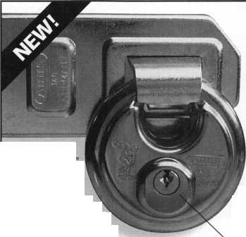

Buyer’s

Guide

AABLE  
Locksmiths

Well once  
again GM has

come out with another ignition lock design,  
and Frank Markisello from AABLE  
locksmiths has designed a tool to simplify  
the removal and replacement of this new  
lock. His tool kit will allow you to remove a  
steel face cap in seconds. Then with the drill  
guide tool you can drill an access hole in line  
with the side bar without hitting the hard  
plate or the side bar. Then you can rake the  
side bar in, so you can turn cylinder to the  
“on” position for fast removal. Then just  
replace the cap and reinstall same lock. The  
first job will more than save you the cost of  
the tool kit! Contact Frank Markisello at  
(718) 847-1377.

Reader Service #8



ABUS

“Urban Tough”  
the Diskus is now  
available in rekeyable  
version #24RK/70.

The improved, now rekeyable, Diskus  
features an all stainless steel lock, inner  
mechanism body.

The shackle is chrome hardened moly  
steel and the lock body is 2.2 mm  
thick. Repinning kits available.  
Contact (800) 352-2287.

Reader Service #9

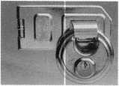

Adesco Safe  
Company

Adesco is pleased to  
introduce the new  
BR2026CVX with  
electronic security and

complete access control. Equipped with the  
Vindicator Lock II, this B-rated safe provides  
your commercial customers with both audit  
control and access control for 100% account-  
ability! Contact Kim Girard at (800) 821-  
6803.

Reader Service #10

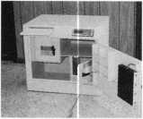

Allstate

Locksmith

insurance

Program

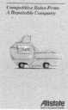

Allstate Insurance Company

The Allstate Locksmith  
Insurance Program offers a  
package of coverage for  
locksmiths with mobile and  
retail operations. A local Allstate  
agent can provide you with

©

“One Stop Shopping” for both your business  
and personal insurance needs. Contact Anita

Bishop at (847) 402-8196

Reader Service #11

Alternative Tools

Here are new tools that  
address problems from an  
alternative point of view.

When the “usual” methods  
cant get it done, try an  
alternative tool. “The Tool”

tension wrench is designed especially to  
allow more room for picks in SCI and KW1  
keyways. “Lever Up” lifts vertical auto lock  
linkage without disconnect danger and  
without the tool entering the vehicle.  
“Paddle Pusher” operates paddles and crash  
bars like you were standing inside. $12.95  
each (+$4.95 S/H). Allow four to six weeks  
for delivery. Send order on back of business  
card with check or m/o to: Alternative Tools,  
Inc.; 162 Robin Dr.; Loveland, CO 80537.

Reader Service #12

BWD

BWD Automotive  
announces the new  
Lockcraft brand  
LC6177(U) and LC6180

Ford 8-Cut ignitions and SK6949 Chrysler  
8-Cut Service Kit. Fitting virtually all 8-Cut  
vehicles, the new Lockcraft LC6177 (U) and  
LC6180 ignitions fit both transponder and  
non-transponder equipped Fords. The  
LC6177 is a coded lock supplied with non-  
transponder keys. The LC6180 is the same  
lock supplied with two transponder keys.  
The uncoded LC6l77U’s one-lock-fits-all  
feature, minimizes inventory and eliminates  
vehicle application problems. Warranty  
terms and conditions available upon request  
Contact (334) 874-9001.

Reader Service #13

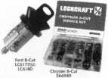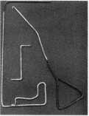

Curtis Industries

New! Code cutting equipment  
is available for Daewoo and KIA!

The new Curtis key tower is

available. Check out our  
special on the 7-piece  
drill-out kit cut by code  
and duplicate with our  
5100 key machine. 150

9002 certified. Contact (800) 555-5397.

Reader Service #14

Defiant

International  
TannVault TL-15,  
manufactured by John  
Tann Ltd., offers standard  
advanced security  
features normally found

in TL30s and higher. Glass plate relocker,  
keylock, collared handle shaft and dial  
spindle provide anti-punch protection;  
keylocking interior cupboard; no body putty  
used to straighten outside corners and legs.  
Nine sizes. Contact (800) 225-2984.

Reader Service #15

Doorking, Inc.

Doorking’s PC  
programmable telephone  
entry systems can now  
control up to 16 different  
access doors in addition

to the main entry door or gate. The systems  
include an 8000 event transaction buffer, can  
report door ajar and forced entry conditions,  
and can activate local and building alarm  
systems. Windows compatible software is  
included with each system. Contact Richard  
Sedivy at (310) 645-0023.

Reader Service #16

Lucky Line Products, Inc.

Stock the most  
affordable key organizer  
available - the Lucky  
Line Key Organizer  
No.61000. Made of  
shatter-resistant

polypropylene, this rugged key cabinet hold  
up to 24 keys. The product installs in  
minutes (screws provided). It measures 8-  
1/2"W x 10-1/2"H x 1 3/4"D and is perfect  
for home, office or garage. Contact: (800)  
654-6409.

Reader Service #17

M.A.G. Engineering & Mfg. Co., Inc.

The new M.A.G. patio  
door lock with bolt  
features a 2" deadbolt for  
maximum security. It  
works on sliding patio  
and hinged doors; works  
on an inside or an outside  
sliding patio door. The

bolt is reversible for greater versatility.

Comes with two small and one large strike

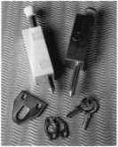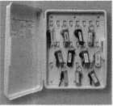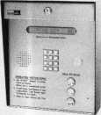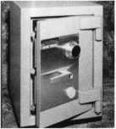

Keynotes

September 1998

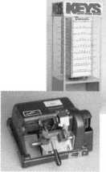

Buyer’s

Gide

plates; aluminum or white finish; keyed  
or unkeyed. Contact Vera Collins at  
(714) 891-5100.

Reader Service #18

MUL-T-LOCK USA, Inc.

The new line of  
MUL-T-LOCK’S Lever

Handle & Knobsets  
provide both strong  
physical protection and  
superior key control at  
an affordable price. All  
lever handles and

knobsets incorporate an MUL-T-LOCK  
cylinder which can be incorporated with  
the rest the of the MUL-T-LOCK product  
line. Contact Michael R. Pennachio at

(800)562-3511.

Reader Service #19

Mas-Hamilton Group

The Mas-Hamilton  
Group, Inc is pleased to  
announce the upcoming  
release of a series of  
standalone electronic  
access control door  
locks. Utilizing Mas-

Hamilton s “no batteries” PowerStar  
Technology, this series provides keyless entry  
and access control, enabling management to  
audit activity and easily handle user-data,  
with a Smart Key. Contact Kelly Kincaid  
(800) 950-4744.

Reader Service #20

Midwest Safe Distributors

It is an absolute  
necessity for  
business owners to  
protect computer  
media from fire.

Midwest safe is now offering an affordable  
solution. The Diplomat Data Safe is a low  
cost great value with a variety of sizes  
available at warehouses located nationwide.  
Contact Lynn Meehan at (800) 713-7233.

Reader Service #21

NKL Industries

AVL (Activity Verifi­cation Lock) is the first affordable Smart Safe Lock. Its quality-crafted features are not available in products costing twice

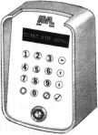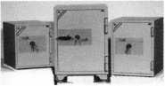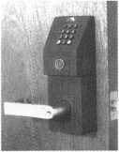

as much. Easy to install, program and use. Features include standard foot print replacement, duress interface, time delay, 500-line audit trail, and more. Contact Bert Chollet at (757) 485-0200.

Reader Service #22

Rutherford Control Inc.

NEW from Rutherford Controls—The Pneumatic Strike—No Electrical Power Required!

Our fire-rated pneumatic air pressure-operated strikes are ideal for hazardous locations, like paint rooms, chemical storage areas, hospitals - anywhere an electric spark may cause hazardous materials to ignite. Contact (800) 899-5625.

Reader Service #23

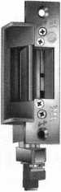

winning Shear  
Aligning Magnalock  
(SAM) is the first  
electromagnetic  
shear lock not

requiring timers or sensors to assure position  
of the armature to lock the door. The SAM  
uses a patent pending conical button  
technology to guide the strike plate into the  
proper position. The springy-smooth, release  
action ejects the strike plate assuring instant  
unlocking without binding. Contact Mark  
Henderson at (800) 624-5625.

Reader Service #24

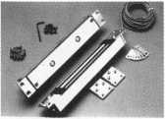

Securitron Magnalock Corp.

The award

Security Lock Distributors, Inc.

Security Lock Distributors has issued  
its catalog of Life Safety and Security  
Products. Security stocks the most extensive  
inventory of hardware products from leading

manufacturers such as  
Arrow, Ives, LCN,

Von Duprin and many  
others. For your free copy  
contact Security Lock  
Distributors. Contact  
David Schwartz at (800)

847-5625.

Reader Service #23

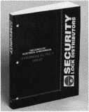

Slydelock Canada

Slydelock Canada is  
proud to introduce the  
SLYDELOCK. This  
unique design is  
engineered to securely  
lock your patio doors in

its tracks. Made of lexan plastic and  
reinforced aluminum alloy tubing, the  
SLYDELOCK lets you “lock open” your door  
by 5 inches. SLYDELOCK offers a life time  
product guarantee. Contact Gilles Pariseaw  
at (819) 770-1020.

Reader Service #26

Milman Manufacturing

Customize your  
key chains to advertise  
your store, company  
or club. Simply send  
us your logo, artwork  
or design and well do

the rest. Contact: (514) 425-5794;

FAX (514) 425-5793.

Reader Service #27

Supra Products

Supra’s new Big Box is a  
great addition to the STOR-A-  
KEY line of key storage items.

Utilizing a push-button lid,  
the Big Box is easy to use in  
residential and commercial

applications. Some Big Box features are:  
access cards fit into larger storage areas;  
accommodates multiple type keys; and  
durable, recessed-lid with tamper-resistant  
design. Contact Debby Bradish at  
(505) 581-9101.

Reader Service #28

Trine Products Company

The new optical  
sensor permits remote  
monitoring of latch bolts  
in EN Series electric  
strikes. It automatically  
confirms positive

latching of a lock set, utilizing a non-  
mechanical Honeywell (R) IR sensor that is  
unaffected by ambient light. The sensor  
continually monitors whether a latch bolt has  
been retracted by transmitting a signal that  
can be implemented either in an audio or  
visual mode. Contact (718) 829-4796.

Reader Service #29

c

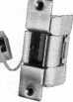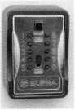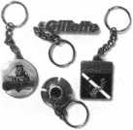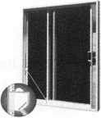

**| 39**

September 1998

Keynotes

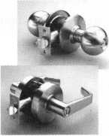

Continental Instruments LLC

Continental Instruments introduced a new Access Control system running on Windows NT. The integrated security sys­tem offers multi-user operation (dozens of workstations), user configurable employee database, integrated alarm monitoring and relay control, operator activity and response logging, video verification, user customized reports, ID badging, extensive help screens and building management functions. The CardAccess 495 NT can utilize existing hardware panels and readers of any encoding technology. Employing a series of field pan­els, the CardAccess 495 NT can support thousands of doors, tens of thousands of card holders, monitor up to 50,000 supervised alarm inputs and control over 25,000 form C relay outputs.

Continental Instruments LLC 250-H Executive Drive Edgewood, NY 11717 ***Reader Service #30***

Trine Products Company

Trine’s new Infrared EN LB optical sensor automatically confirms positive latching of a lockset within any Trine EN Series Heavy Duty Electric Strike. It utilizes a nonme­chanical Honeywell IR sensor featuring a weather resistant heat sink module and is unaffected by ambient light. There are four sensitivity settings allowing adjustment for various latchbolt configurations. The Security Sensor option is available on 10 EN Series Electric Strikes. It permits remote monitoring of a door’s secured condition by confirming engagement of the lockset and electric strike. It continually monitors whether a latchbolt has been retracted by transmitting a signal that can be imple­mented it either an audio or visual notifica­tion system.

Trine Products Company 1430 Ferris Place Bronx, NY 10461-3699 (718) 829-4796 (718) 518-7022fax [gary@trineprod.com](mailto:gary@trineprod.com)



Reader Service #31

***Keynotes***

September 1998

Onset Computer Corporation

The HOBO Pro Series data loggers are 100 percent weatherproof and can record up to 65,291 temperature and humidity mea­surements. The battery-powered loggers have RH accuracy of +3 percent from 0 to 100 percent RG and temperature accuracy of +0.5°F from 0° to + 160°F with 12-bit reso­lution. The case is specified to withstand a five foot drop and can survive years in wet or condensing environments. Data is kept in EEPROM memory that preserves data even if the battery fails and a unique data archiv­ing feature provides additional data backup. Data is readout to a PC with a BoxCar Pro software, and can be graphed or exported. **Onset Computer Corporation PO Box 3450 Pocasset, MA 02559-3450 (508) 759-9500 (508) 759-9100fax [sales@onsetcomp.com](mailto:sales@onsetcomp.com) Reader Service #32**

SecuraKey

SecuraKEY announces the addition of keypad entry to the RadioKey 600 proximi­ty access control system. Radio Key 600 allows any of up to 600 users to be assigned either a Proximity Key Tag or a PIN Code to gain entry. The Radio Key 600 is weather resistant and is designed for indoor or out­door use. With the addition of the RKAT Audit Trail Module, the Radio 600 can drive a serial printer or communicate with a PC using RK-LINK software, a Windows ’97/NT program that allows the user to print reports, program, back-up and control the Radio Key 600.

Secura Key 20447 NordhoofSt.

Chatsworth, CA 91311 (818) 882-0020 (818) 882-7052fax [mail@securakey.com](mailto:mail@securakey.com) http:ll[www.securakey.com](http://www.securakey.com) ***Reader Service #33***

American Lock Company

American Lock Company introduces a 2- 3/4” solid brass rectangle lock with a pro­tected, locking - bolt shackle. The lock, also known as a “warehouse lock,” is used to secure self-storage facilities, garages, store­front roll-up doors and coin operated devices, such as newspaper vending machines. It is designed to endure harsh weather conditions and temperature extremes.

American Lock 3400 W. Exchange Crete, 1160417-2099 (708) 534-2000 (708) 534-0531 fax ***Reader Service #34***

Chicago Lock Company

Chicago Lock Company recently intro­duced BarLOC, which features a rotary disk tumbler mechanism with a front anti-drill plate and a hardened steel body and shackle. It’s offered in three body sizes and designed with interchangeable shackles. The shackles, available in three lengths for each body size, are easy to change. A large plastic key han­dle provides ease of operation. The key may also be inserted in either direction.

Chicago Lock Company (800) 445-3204

Reader Service #35

Jet Hardware

Jet Hardware recently unveiled two new key blanks. They consist of the plastic head HU66VW-PH to fit the new Volkswagen Beetle and Passat. The second key on the release is the PZ1 to fit Papaiz. A new cata­log has also been released featuring 100 new keyblanks including transponder and licensed keys plus the new ETD-1 Electronic Transponder Decoder and Duplicator.

Jet Hardware Manufacturing Group 800 Hinsdale St.

Brooklyn, NY 11207 ***Reader Service #36***

Security

Marketplace

Security Lock Distributors

All Security Lock Distributors warehouse centers offer multiple door management capability via the complete Keri Systems line of controllers, proximity readers and Windows software. Keri’s PXL-250 Tiger Controller can service from one to 256 doors. It is a proximity-based access system provid­ing 100 percent intelligence at each door and is expandable one or two doors at a time. It features RS-232 serial port for direct connection to PC or by m modem to multi­ple sites, 10,0000 plus user capacity and can support Keri Proximity or any Wiegand- Compatible Reader Technology.

Security Lock Distributors

(800) 847-5625

(800) 878-6400fax

[SECLOCK@IX.NETCOM.COM](mailto:SECLOCK@IX.NETCOM.COM)

<http://seclock.com>

Reader Service #37

Thomson Industries, Inc

Thomson Industries is offering a free 186- page catalog featuring 17 types of RoundRail and ProfileRail linear guides. This catalog provides a reference tool for design engineers and specifiers of linear guides. Featured in the catalog are linear guides with different contact technologies (ball, roller, sliding bearings); mounting types (fully supported, unsupported, end supported) and mounting styles (above, below, side).

Thomson Industries, Inc.

2 Channel Drive

Part Washington, NY 11050-2214 (516) 883-8000 (516) 883-9039fax ***Reader Service*** ***#38***

What’s New in Tools for Technicians

“Poxy Pouches” are individual packages that contain general purpose liquid epoxy adhesive to repair metal, glass, mbber, plas­tic and ceramic parts. Sets in five minutes. “TAK PAK 444” is an instant adhesive designed for printed circuit board assembly and repair. Replaces epoxies, silicones, hot melts for mounting components, reinforcing stand-offs, wire tracking and board repair. Two-part system with accelerator cures instantly. RTV Sealant 5145 is specifically formulated for boding sealing and coating of electronic devices. Ideal for reinforcing and strain relieving delicate components.

What’s New in Tools for Technicians, a service of Jensen Tools, Inc.

7815 S. 46th St.

***Phoenix, AZ 85044*** Reader Service #39

**1998 TRI-REG ION AL CONFERENCE**

1973 25TH ANNIVERSARY 1998

hosted by

PACIFIC LOCKSMITH ASSOCIATION  
OCTOBER 19-25, PORTLAND, OR

FOUR DAYS OF CLASSES

•Master Keying ‘Safe Openings ‘Basic Locksmithing • Lockpicking

•Impressioning *ADA ‘Tubular Locks ‘FREE Evening Clinics

•Safety Deposit Boxes ‘Domestic/Foreign Auto ‘Social ‘PRP Test

•Factory Certification Classes

TWO DAYS OF TRADE SHOW

•See New Locks & Tools ‘Get Latest Brochures and Prices

•Talk to the Factory Reps ‘and Win Some of the Many Door Prizes

For registration and exhibitor information  
contact Stan Hauer, Co-Chairman  
Hauer’s Cydery & Locksmith, 1606 Marine Dr., Astoria, OR 97103  
Phone/Fax: (503) 325-6003 Email: [hauer@pacifier.com](mailto:hauer@pacifier.com)

Reader Service #40

***Keynotes***

41

September 1998

Keynotes

Authors



Mike Emery is the associate editor

^Keynotes and a freelance music writer.

42

Authors featured in this issue of Keynotes:

Paul Chandler, CRL, is the manager of the Electronic Security Department for I. D. N. - ACME in Houston, Texas. He was named "Keynotes' Author of the Year” for 1998.

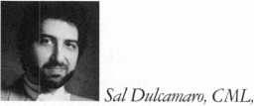

the locksmith business for over 23 years. He is the  
president of All Pro Security, Inc. in Michigan and  
has been an ALOA member for 16 years. A past  
president of the Locksmith Security Association of  
Michigan. Sal currently serves as editor of the  
association newsletter. He was named "Keynotes  
Author of the Year” for 1996 and 1997.

Tim McMullen oversees govern-

mental affairs for ALOA as well as acting as the  
liaison to ALOA chapters and regional associations.  
He is a graduate of the District of Columbia School  
of Law and has an extensive background in  
legislative work.

Mark Ohno, manager of the Kolram Security Group has collected cutaway locks, padlocks, hotel keys, lock company memorabilia and many other items unrelated to locks, is a life member and formerly served on the board of directors of the Lock Museum of America.

Steven B. Spiwak, CRL, is a

fourth generation locksmith who specializes in a  
variety of areas including crime prevention and insti-  
tutional security. His broad experience in the security  
field spans 20 years of ivriting, teaching and  
consulting for a number of corporations. Most recently  
he formed Lockport, Inc.—a security consulting  
company for industrial, commercial, institutional  
and governmental clients.

Kathy Zaniolo, CPL, co-owns Personal Home Safety in Oak Park, Illinois. She has been instru­mental in regional legislative affairs in her home state.

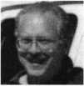

The Yankee Security Conference

13 trade-related courses taught by the industry’s best instructors

This year introducing A.L.O.A - A.C.E. certified classes

New England’s Premier Trade Show

Free Pre-registration (includes free parking)

CLASSES

October 21-23, 1998

TRADE SHOW October 24-25, 1998

Rhode Island Convention Center Providence, Rl

Don't miss our 20th year 1978 - 1998

Reader Service #42

Keynotes

September 1998



Don’t let disappear i

Monday,  
September 14,

for pre-registration

Sorry. If you miss  
this date, you  
will have to  
register at the  
convention center.

**Dor** and istitute.

packet call tfi Hardwai

703/222-2010

Escape the pains of last-minute planning!

Register in advance

for the Door and Hardware Institute’s 23rd Annual Convention and Exposition! October 31 - November 2 in Orlando, FL

WHATS IN IT FOR YOU?

See More

Visit more than 415 exhibitor booths at the most comprehensive industry trade show you’ll attend this year.

Experience the latest technology at the trade show’s “Electronic Security Row,” which provides great products in one location for all your access control needs.

Meet instructors and business people who can update you on the latest trends, products and devices of the new year.

Learn More

Choose from six tracks of education with more than 24 sessions.

Participate in roundtable  
education sessions, where  
you will interact with other  
attendees and industry  
renowned instructors.

Earn credentialing points.

Experience More

Don’t miss this year’s Opening Night Reception, which offers a Halloween costume party, where you can mix business and pleasure in one lively place.

Sign-up for tours of Kennedy Space Center, Sea World or Winter Park.

Win one of several fabulous door prizes to be awarded throughout the weekend.

Reader Service #43

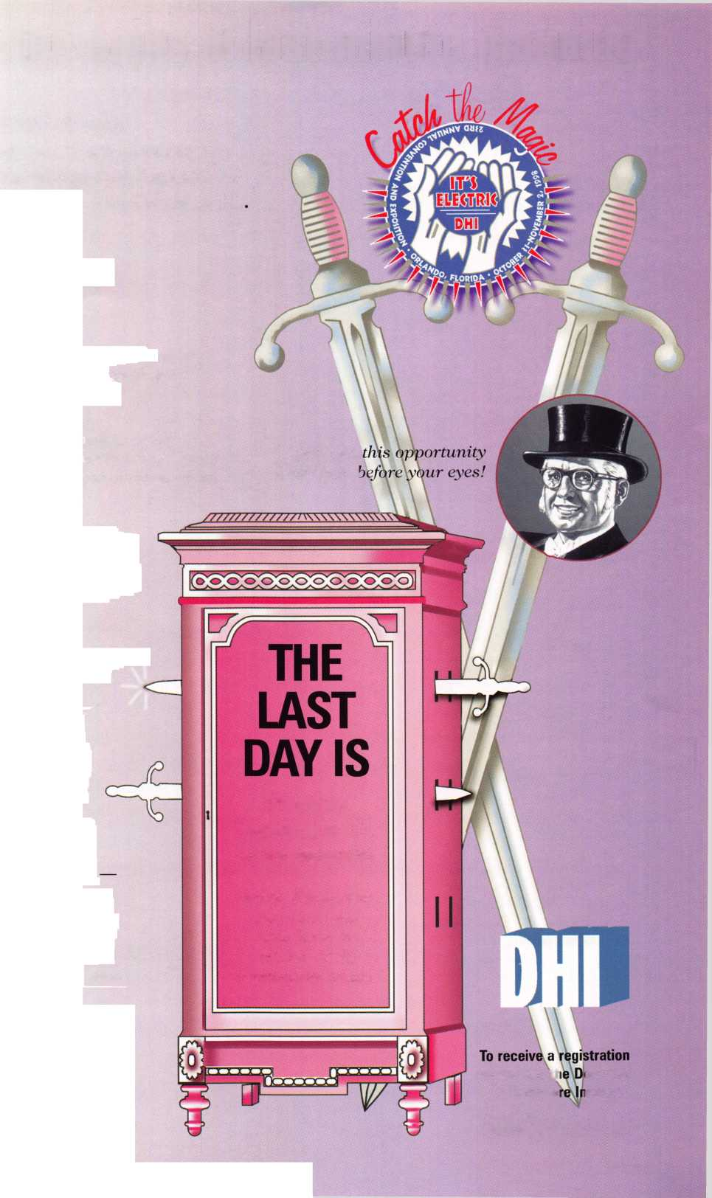

**ALOA Art Appreciation Quiz**

Keynotes

Give Me the Shirt

3003 Live Oak Street

Dallas TX 75204

or fax to (214) 827-1810

or email to [keynotes@anet-dfw.com](mailto:keynotes@anet-dfw.com).

We’ll draw a winner from the correct responses.

□

□

□

□

□

Another victim of discount  
plumbing.

A college kid trying to get into  
some fraternity.

The Genius of Water standing  
atop the Tyler Davidson Fountain  
on Fountain Square in Cincinnati,  
Ohio, home of the ALOA ’99  
Convention and Security Expo,  
July 25-31.

Some really tall person with  
really really sweaty palms.

The bathtub faucet in Donald  
Trump’s penthouse.

If the aesthetics of Cincinnati’s water world aren’t of all that much interest to you, how about riverboat rides, huge water amusement parks and canoe trips through wooded hillsides? We’ll be back with more on that, and with more Cincinnati ALOA ’99 prizes.

September 1998

Okay, here at Keynotes we believe that you don’t need to be an art critic for the New York Times to critique a statue. So we have done a quick locksmith survey about this one and here are the top five answers—one is actually correct. If you can pick out that answer and want a spiffy black ALOA golf shirt, send your entry to:



You wouldn’t dream of leaving your success to chance. You know that making it in the safe and vault industry requires hard work, continual improvement of techniques, and constant research of the latest products and tools.

Your best bet to excel in all these areas is SAFETECH ’99 where you can save your luck for the casinos, and get down to business viewing the latest products, talking with the manufacturers, and training in the latest methods of safe and vault technology.

Make your plans now to attend SAFETECH ’99 May 3-8, 1999 in Las Vegas, NV.

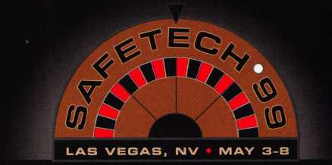

Contact:

Safe and Vault Technicians Association

3003 Live Oak Street Dallas, TX 75204 214.827.7233 214.827.1810 fax email: [convtion@anet-dfw.com](mailto:convtion@anet-dfw.com)

**Don't Be Locked**

**Out of the Electronic Auto Transponder Key Market**

'■'i

Tol

The Jet etd-i ...

Transponder Key Duplication made Easy.

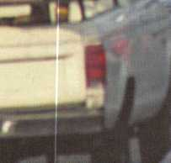

Don’t be locked out of the growing market of electronic anti-theft automotive security. This easy-to-use decode quickly and accurately duplicates the most popular transponder keys, including: CADILLAC CATERA, HONDA, ACURA, MAZDA and AUDI / VOLKSWAGEN. Included with your purchase are 5 each of the above keys (a value of $ 295.00), along with a colorful window decal.

Available through your favorite JET distributor.

JET HARDWARE MANUFACTURING CORP

800 Hinsdale Street, Brooklyn NY 11207

Reader Service #100

